

ORIENTEERING LESSON PLANS
FOR TEACHERS

INTRODUCING BASIC
ORIENTEERING SKILLS

This pack has been designed to enable teachers to deliver orienteering activities to pupils within the grounds of their school.
The activities suggested only require basic equipment and all resources and sample maps are included in this pack.

BSOA have a range of kit that complements some of the lessons. This can be found at www.bsoa.org under SHOP.

We would also recommend that Teachers attend one the Teaching Orienteering courses organised by British Orienteering. These can be found at www.britishorienteering.org.uk in the Training Courses section under Coaching.

Contents Page

Table Top Maps | 3
First Steps – Simple Map exercise | 4
Gym Map – Indoor Orienteering | 5-11
Cone Orienteering | 12 | – 18
Netball Numbers – Star Exercises | 19 | – 26
Netball Number Courses | 27 | - 30
Badminton Courses | 31 | - 34
Tennis Court Courses | 35 | – 38
Tennis Court Star Exercise. | 39 | - 46

Table Top Maps

Resources:

- Table or desk

- Several simple objects

- Paper, pencils, crayons

The Session:

- Layout some simple objects on the desk, make sure they are different shapes and sizes.

- Ask the children to imagine they are a bird flying above the desk looking down; show them what it would look like on a map. This maybe a map of pictures of the object or specific symbols to represent the different objects. Discuss what sizes the individual shapes are and how they relate in spatial positioning to each other.

- Teach them to set the map so that what is on the right on the desk is to the right on the map.

- Place the objects in a different position. Can the children draw the map of the new shapes?

- Move to a different side of the table; is the map correct now? Practice moving around the map to keep the map correctly set to match the objects.

You can also do the same exercise using a mat in the gym instead of the desk top.
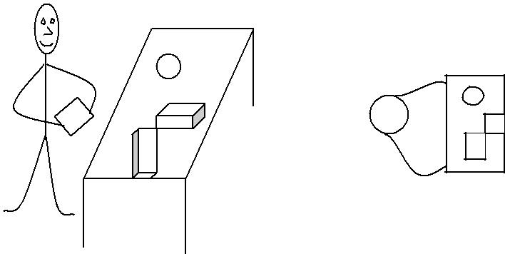

3
First Steps - Simple Map Exercise

Resources:

- 3 simple shapes (crash mat, bench, hoop, or shapes made with cones or newspaper)

- Maps - One copy of the map below for each child.

- Colour markers on page 2 of this document. Different colour for each pair.

The Session:

- Sit children in pairs around the edge of the area. Four chairs in the corners can help mark out the area.

- Match the map to the ground. i.e. orientate or ‘set’ the map.

- Point to where they are on the map.

- Teacher/leader walks around the shapes, children follow with finger.

- Give each pair a marker. One from each pair points on the map where to place the marker. Other places it and returns. Retrieved by partner to check correctly placed. Swap over.

- One of the pair faces away from the area and the other places marker as in 5 above. Show partner on map for them to retrieve. Did they get it correct or did they have to search for it?

- Practice moving around the edge of the area, keeping the map set at each turn.
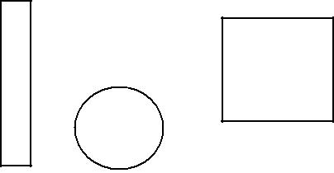
Progression

- Increase the number of shapes.

- Set out courses of 2 or 3 controls.
Gym Maps

The following set of maps can be used for orienteering sessions in a hall/gym.

Gym Map – No controls printed on the map

Resources:

- One map from page 2 per group.

- Cones or markers to divide the hall into sections. One section per group.

- Selection of gym equipment e.g. gym mats, hoops, cones, ropes

The Session:

Give each group one map and allocate a section of the hall for them to work in. Ask each group to select and lay out equipment as shown on the map. Discuss and demonstrate map orientation. Pupils practice moving round the map keeping the map orientated as they progress.

Gym Map - With controls printed for gym orienteering

Resources:

- Teacher maps for equipment and control placement from page 8.

- 7 controls lettered B, C, K, T, A, E and R from page 8.

- Answer sheet from page 10.

- Maps numbered 1 to 8. For a class of 30 you will need to print off 2 sets.

- Selection of gym equipment. e.g. gym mats, hoops, cones, benches.

Setting Up:

Put out gym equipment and control placement using the teacher map.

The Session:

Issue one map per pair. Discuss map orientation and where the start is. Pupils must visit controls in order given on the map. They record answers, if correct try a different map.

5
Gym Score Event

Resources and Setting Up

- Same as for gym orienteering except prepare copies of the score event map on page 10 instead of the numbered map.

- Pencil and paper for each pair.

The Session:

Issue one map, pencil and paper per pair. Discuss map orientation and where the start is. Allow one minute to locate as many controls as possible and record the answers. Option to change the control letters so that when re-arranged the pupils work out an anagram.

6
Gym Maps - No controls Printed

7
Gym Map with Controls for Gym Orienteering

8

10
Copy first 7 letters (control) for use with maps above. Additional markers may be used as alternatives.

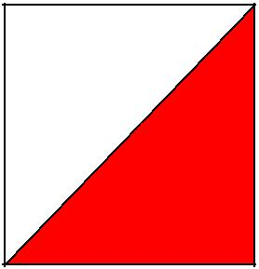
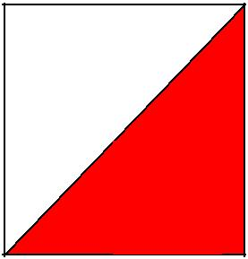
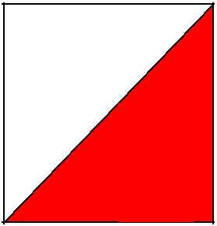
C
B
K

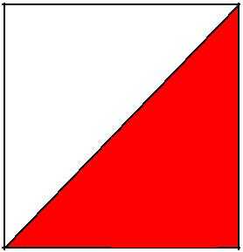
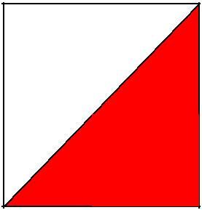

T
R
E

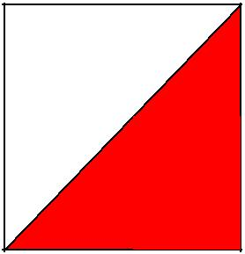

A
G
J

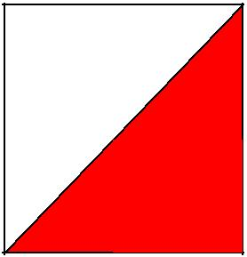
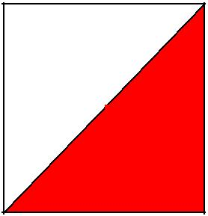
N
P
Q

R
V
X

11

Cone Orienteering

Resources:

- 3 blue cones, 3 yellow cones, 3 green cones and 3 white cones.

- Cone maps from below. For a class of 30 you will need one copy of map 1 for each pair and 3 copies of maps 2-6.

Preparation:

- Set out the 12 cones in a grid as given on the map. Leave a space of 2 metres between each cone.

- Put children into pairs.

The Session:

- Practice map

  - Give each pair a copy of map 1.

  - Discuss map orientation and ask each pair to set the map to the cones on the ground.

  - Ask each pair to go to the start cone (red triangle on map).

  - Discuss - is everyone in the correct place?

  - Select one pair to lead the class to the next cone, discuss location and if correct continue until the class reach the finish cone at the double red circle.

- Pair work

  - Give each pair one map numbered between 2 and 6.

  - Each pair starts at the cone marked on their map. They navigate to each control until the finish.

  - You check they have finished on the correct cone.

  - Swap maps and repeat.

Extension Activities:

Assessment :- Put codes on each cone. Give each pair a pencil and paper; they record the code of each cone they visit along the route.

Black and White Maps :- See example map at the end of this document. Make more maps with different courses. Set out a grid of 12 cones of any colour and run session as for colour coded cones.

12
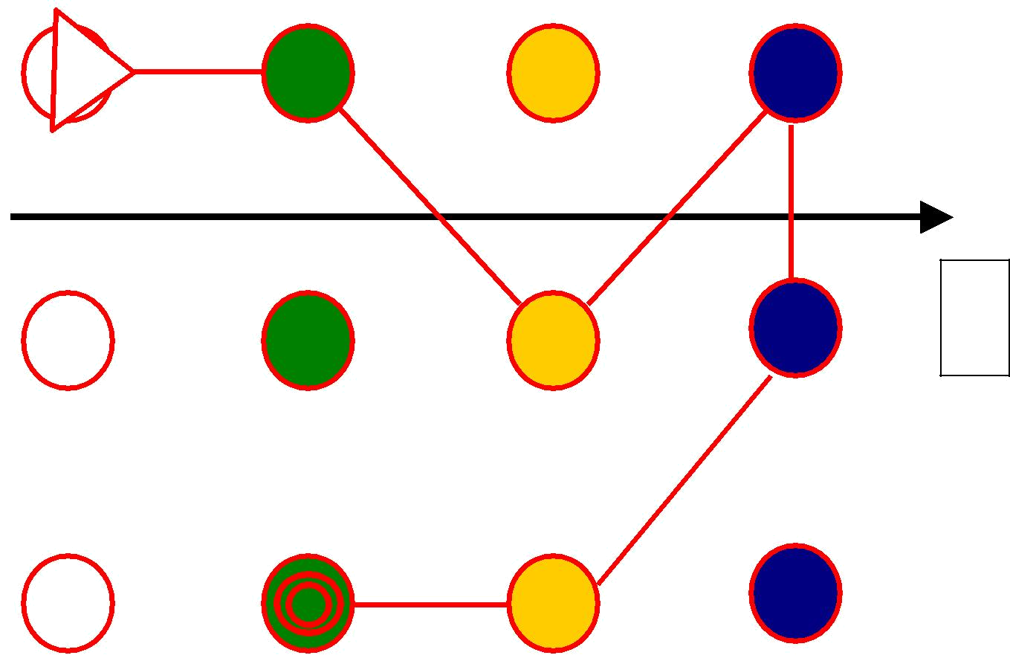

Map 1

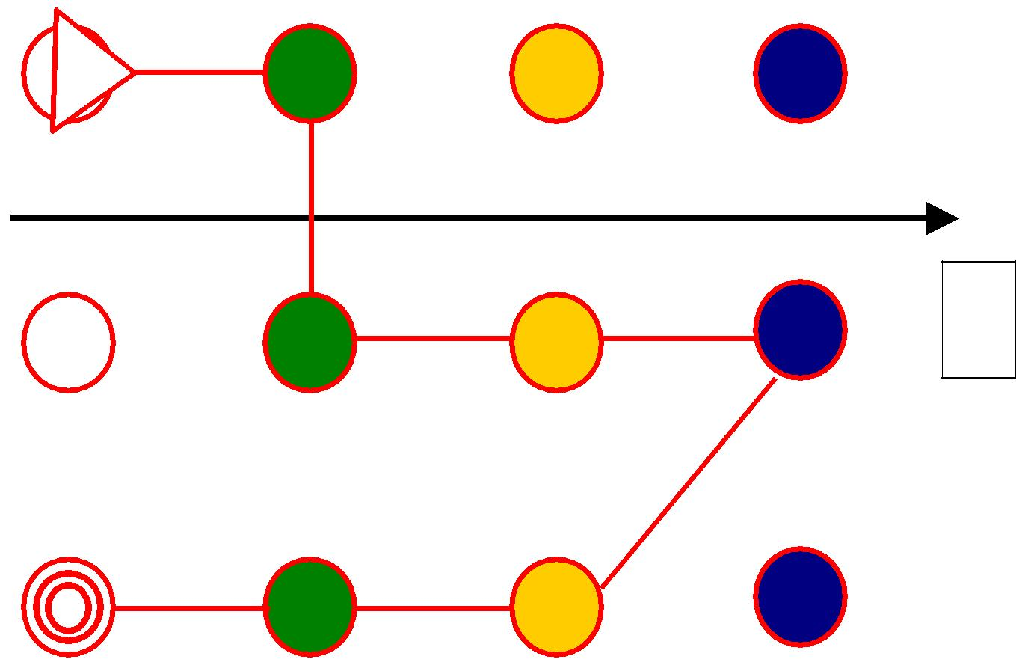

Map 2

13
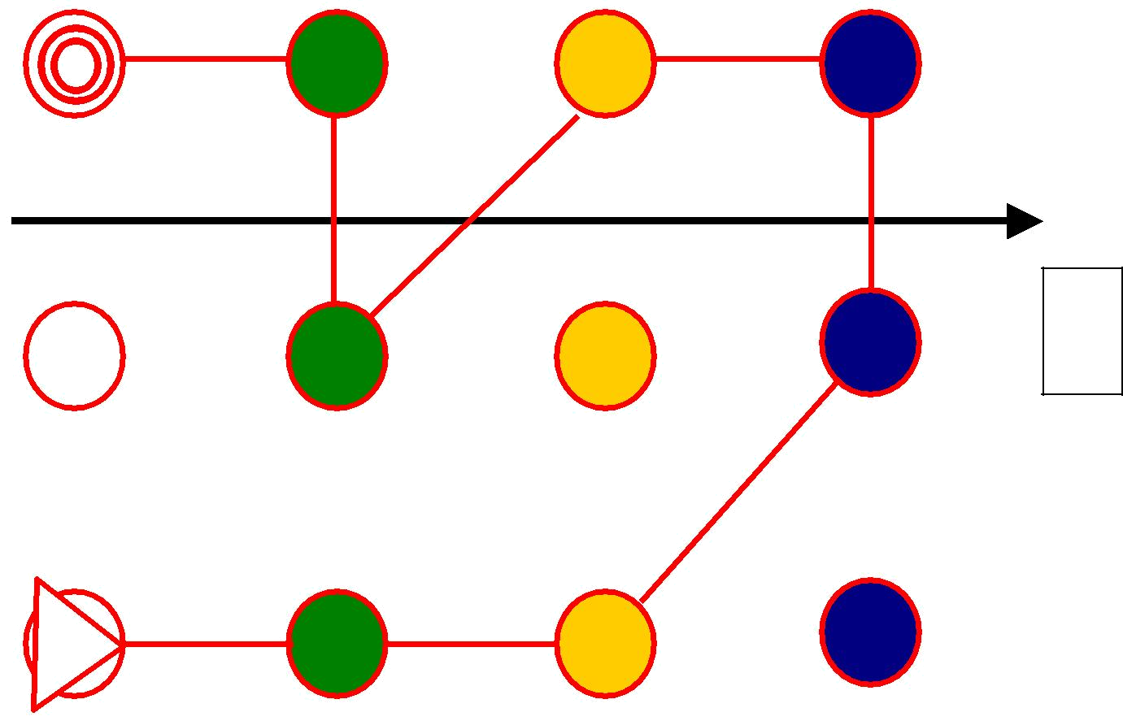

Map 3

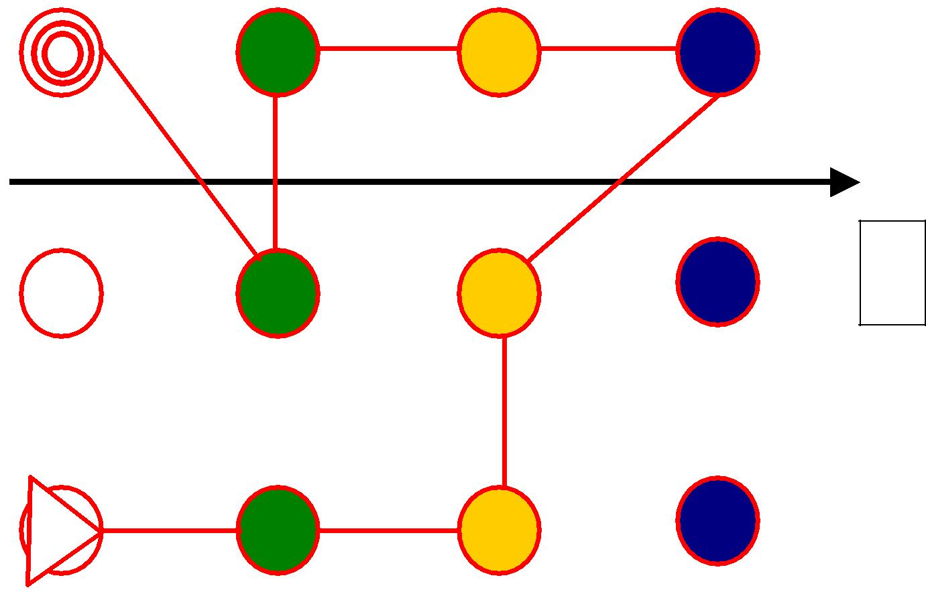

Map 4

14
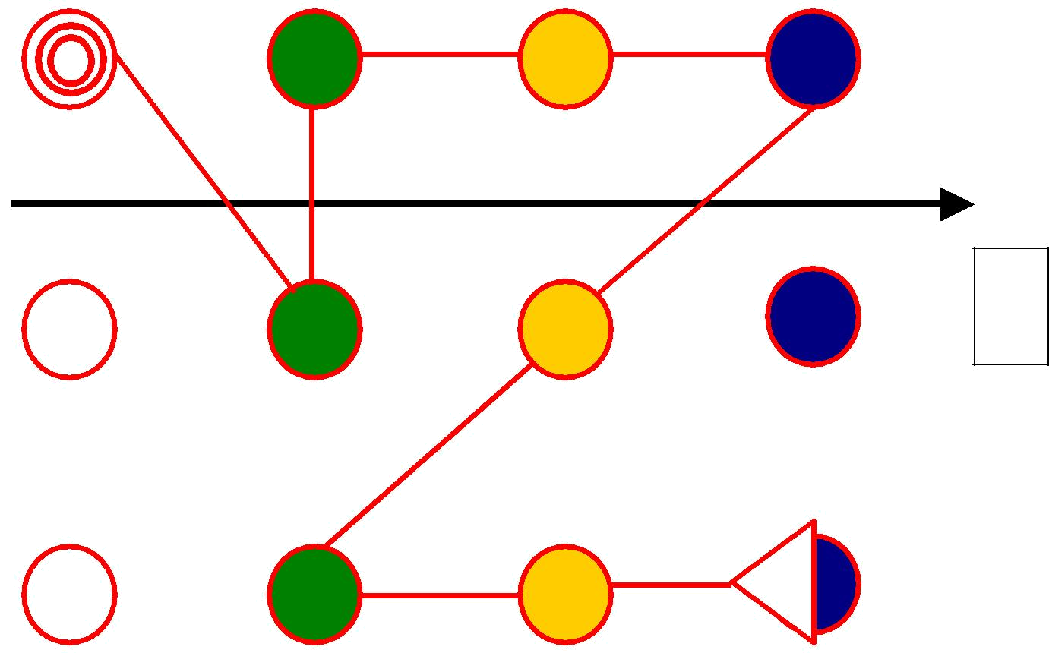

Map 5

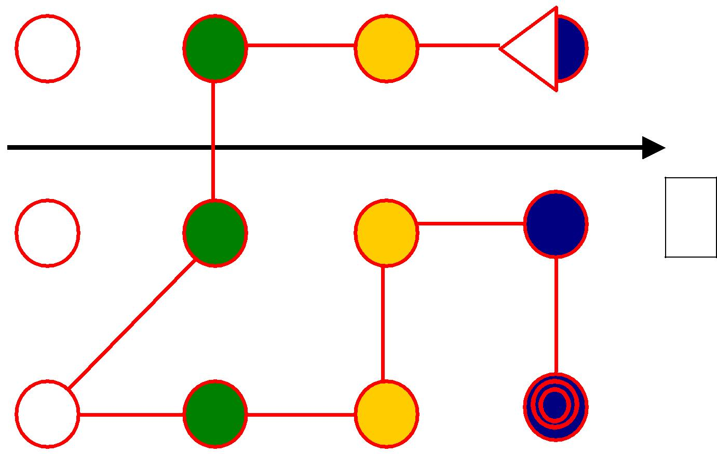

Map 6

15
Cardinal Cones Map Courses

Resources:

- 9 markers – e.g. cones, upside down plant pots, cards pegged into the grass, each one with a north arrow and a code letter

- Large north arrow placed at the appropriate end/side of the area to be used

- Make a few (4 or 5) copies of the course maps, cut up the maps and laminate each one.

- Sets of cardinal cones maps. Put each different course map in separate bags or boxes which are clearly labelled with the course number

- Slips of paper and pencils

- Answer sheet

Preparation:

- Put out the markers in three rows of three as shown on the diagram bottom right, taking care to put the correct code in the right place according to a pre-determined plan

- Prepare an answer sheet for each course map

- For a class it may be preferable to have 2 or more sets of grids in the area so as to avoid congestion

The Session:

- A warm-up activity which revises the compass directions is a good idea e.g. all jog round and when the whistle is blown call out a direction (North, south, north east etc) and they all run to that side or corner of the area

- The children should be in pairs

- Explain that:
o The map does not show all nine cones but just the ones needed on the course

- The triangle on the map represents the start and the information on each map tells them which marker on the grid is the start place for that course

  - Each course finish point is marked on the map with a double circle and is the same as the start point

- The children should keep that map orientated so that the north lines on the map always point to the northern edge of the area (as indicated by the large north sign or arrow)

- In each pair one child is responsible for navigating whilst the other notes the code letter at each marker which is visited on the course, including the start and finish place

- Pairs come and check their answers and if correct they take a different map.

- Swap the navigating and answer writing roles each time

- Continue in this way until the time is up or everyone has completed all the maps.

16
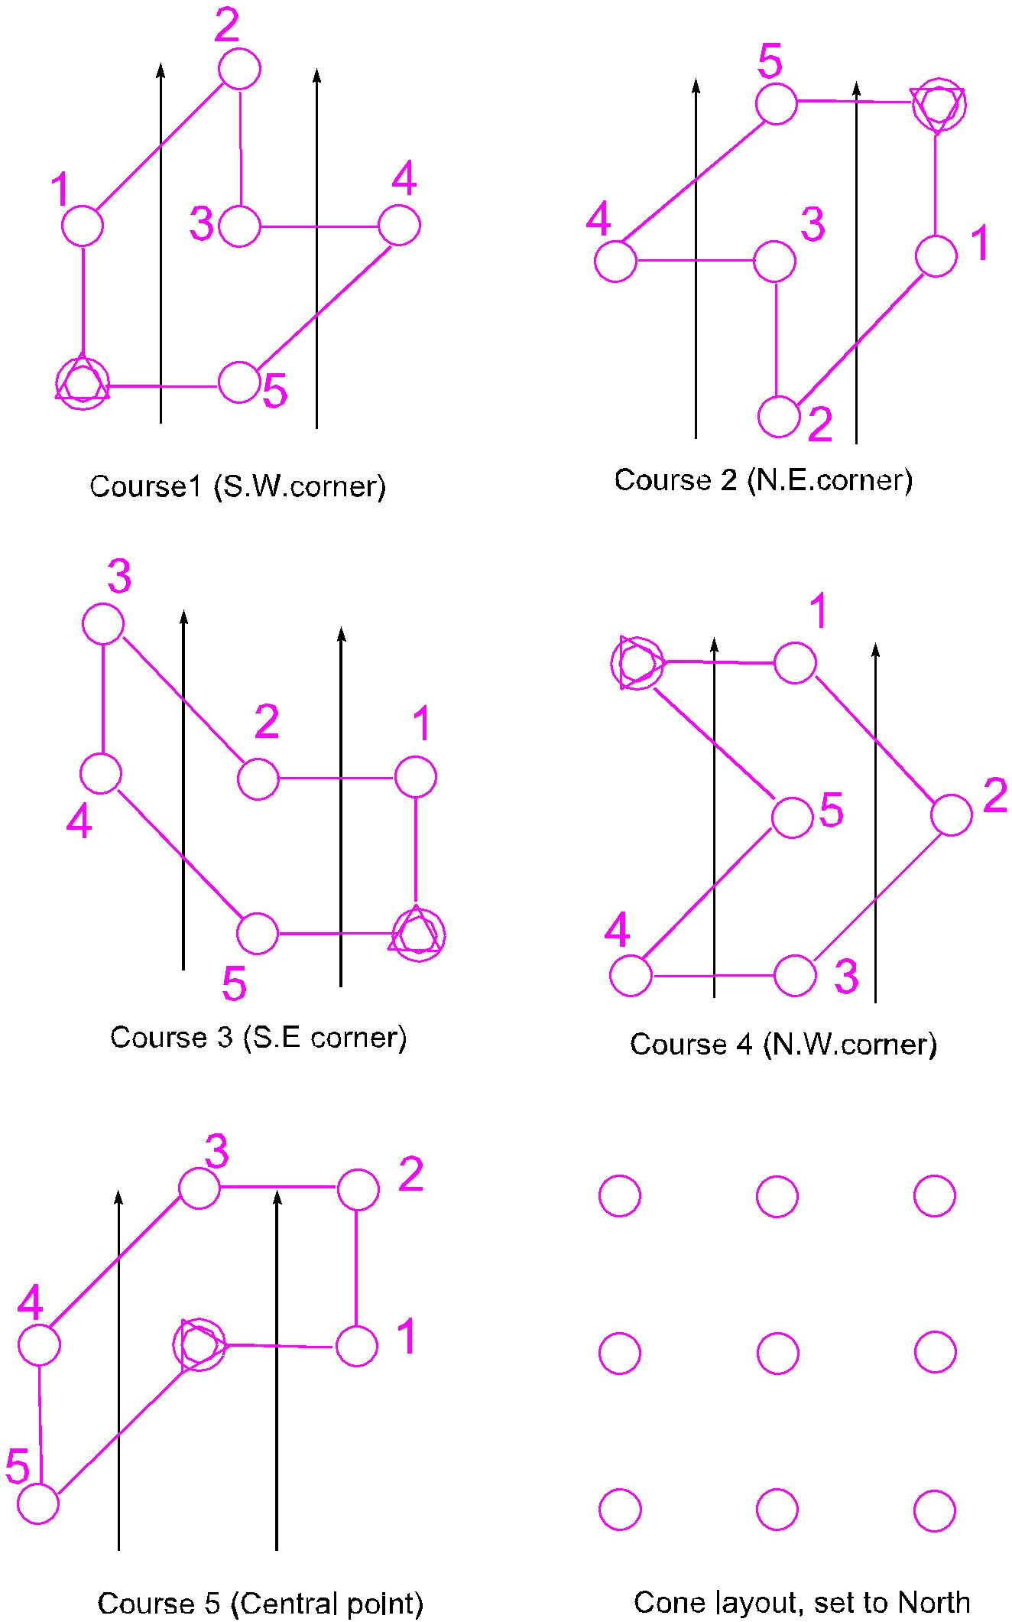

17
Example: Black and White Map for Extension Activity for 12 cones
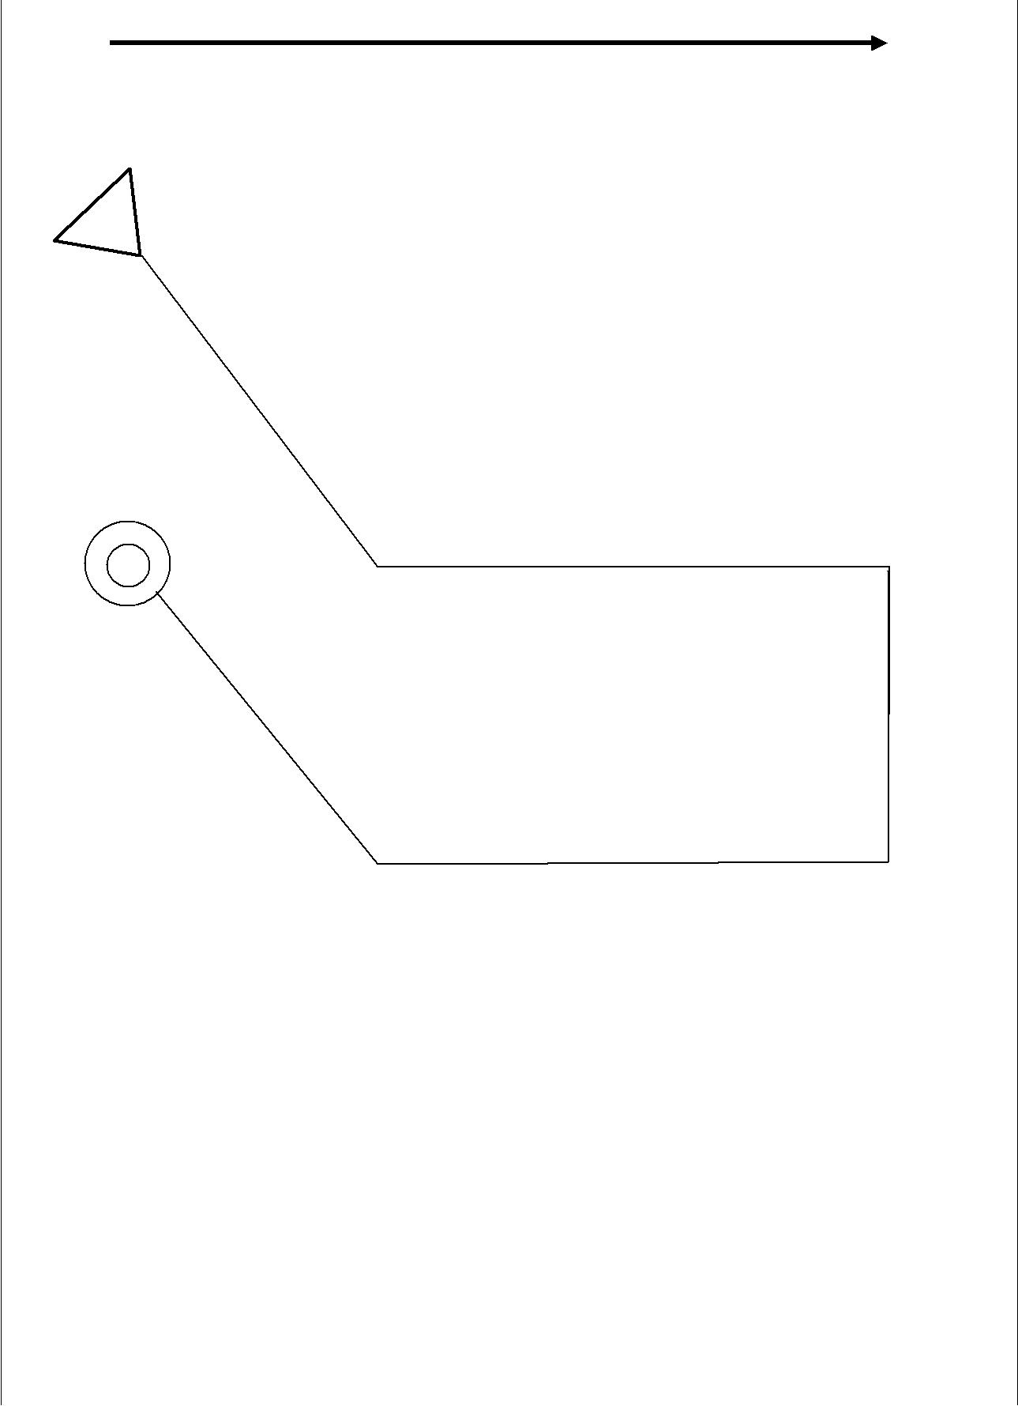

X | x | x | x
x | x | x | x
x | x | x | x
 |  |  | 18

Netball Numbers - Star Exercise

Resources:

- Netball court maps, 14 maps with sufficient copies of each map to have one per pair with a few left over. Each set of maps to be placed in separate box or bag.

- 14 cones or markers labelled with the code numbers as follows:

- 4 with number 1
- 4 with number 2
- 4 with number 3
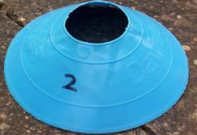
- 2 with number 4

- Answer sheet

Preparation:

Put out the cones on a netball court as per the diagram, taking care to position them accurately. Make a start triangle on the ground with red cones

 |  | 3 |  | 2 | 4
 |  |  |  |  | 4 | Answer Sheet
 |  |  |  |  |  | (The value given to
3 |  |  |  |  |  | each letter)
2
A,G,F,L = 1
B,C,E,K = 2
D,J,M,P = 3
H,N = 4
2
2 | 1 | 1 |  |  | 1
 |  | 4 |  |  | 2
 |  |  |  |  |  | 3
1 |  |  | 3
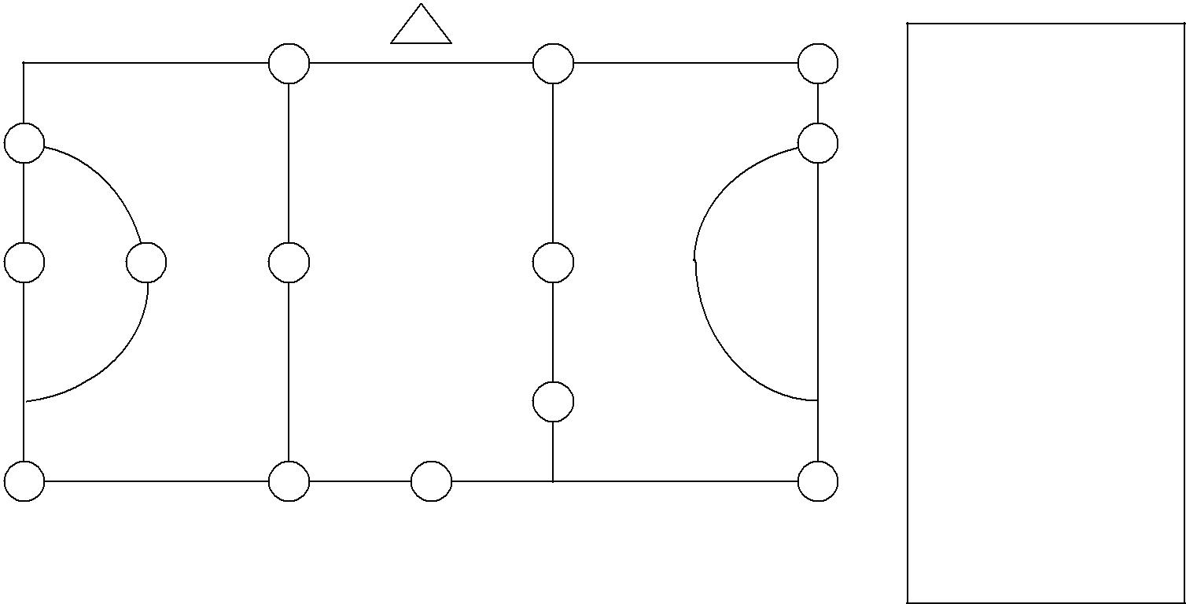

The Session:
- The children should be in pairs

- Explain that the triangle on the map represents the start.

- Give child 1 the map of one marker, child 2 is responsible for remembering the code number they find on the cone for the map they are doing.

- Give successive pairs different maps to start with; so they don’t follow each other.

- When a pair returns with the correct answer give them another map, this time child 2 has the map and child 1 remembers the number. Swap roles each time they start a new map.
- Continue in this way until the time is up or everyone has completed all the maps.
19
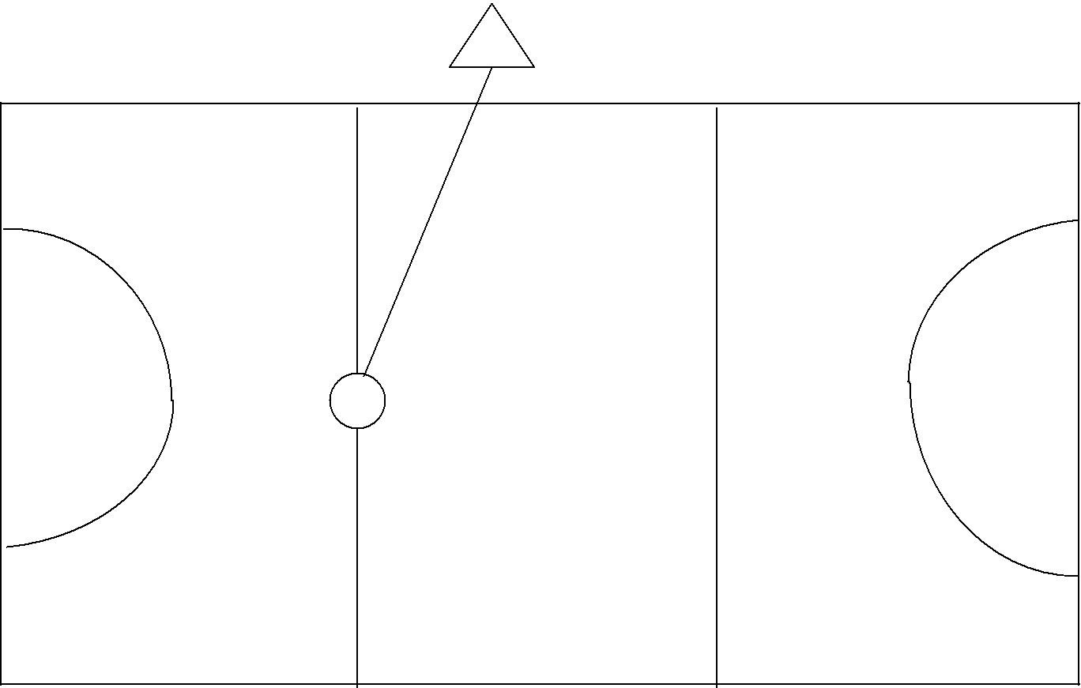

A
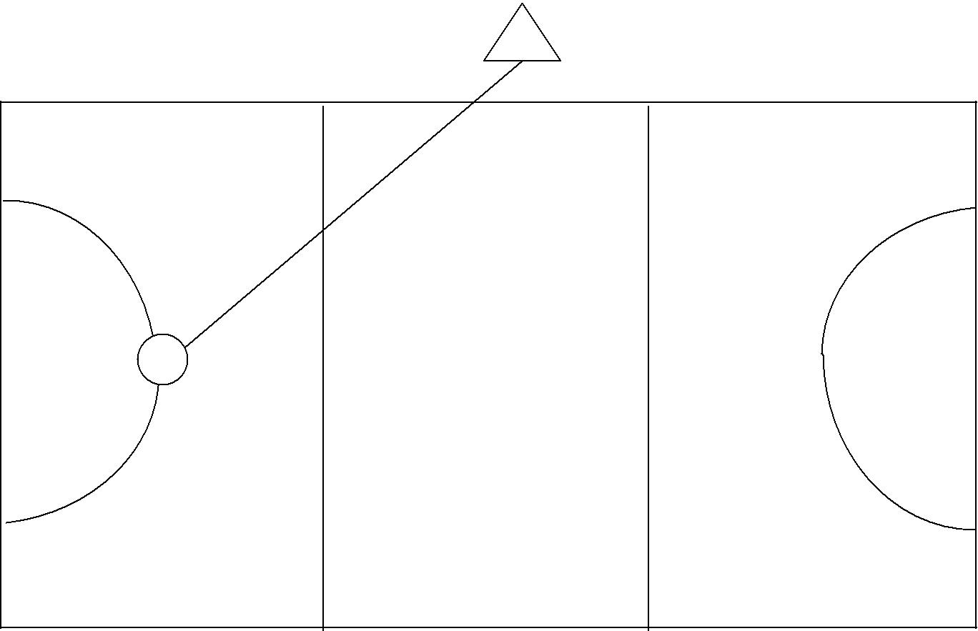

G

20
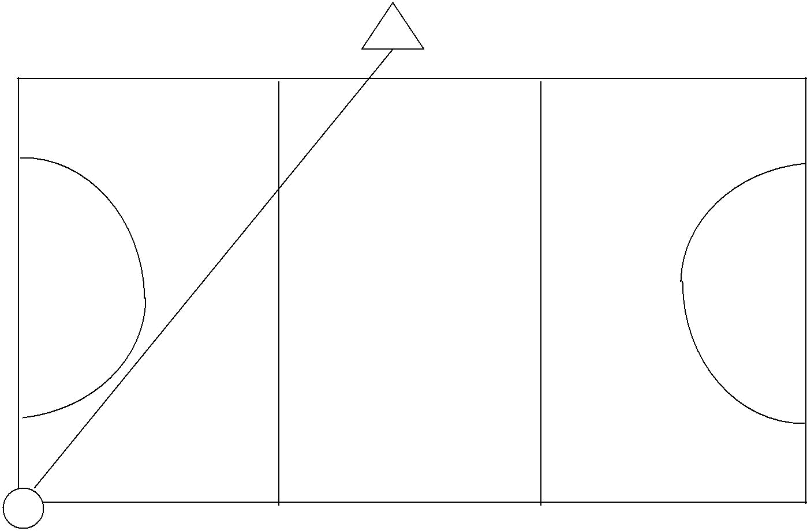

F
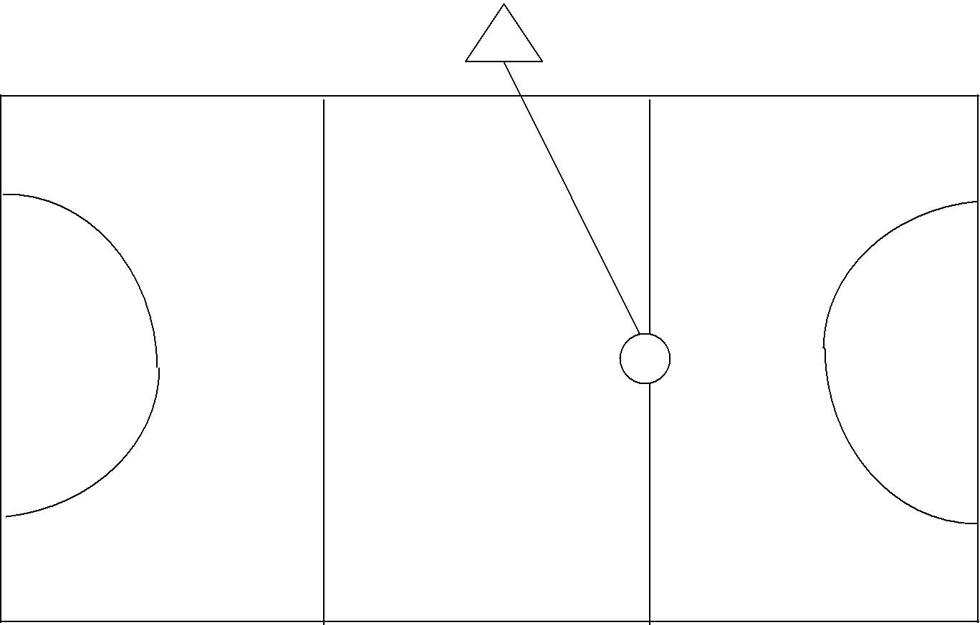

L

21
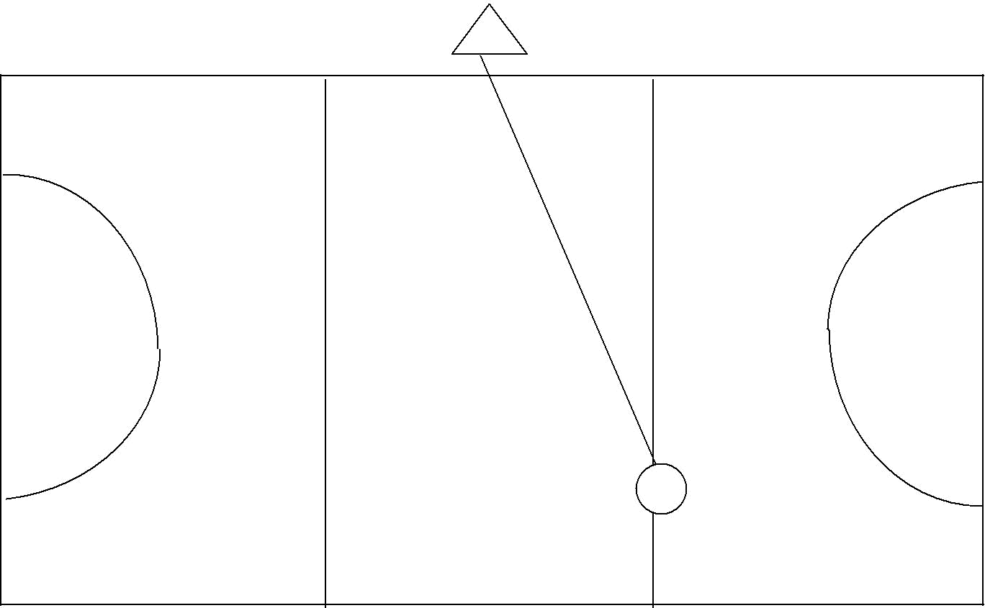

B
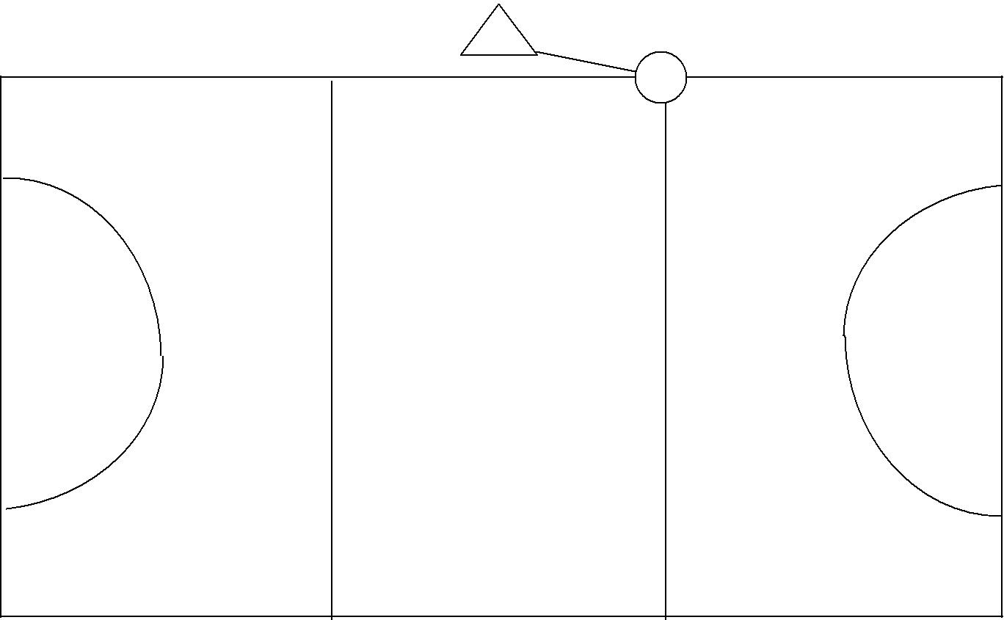

C

22
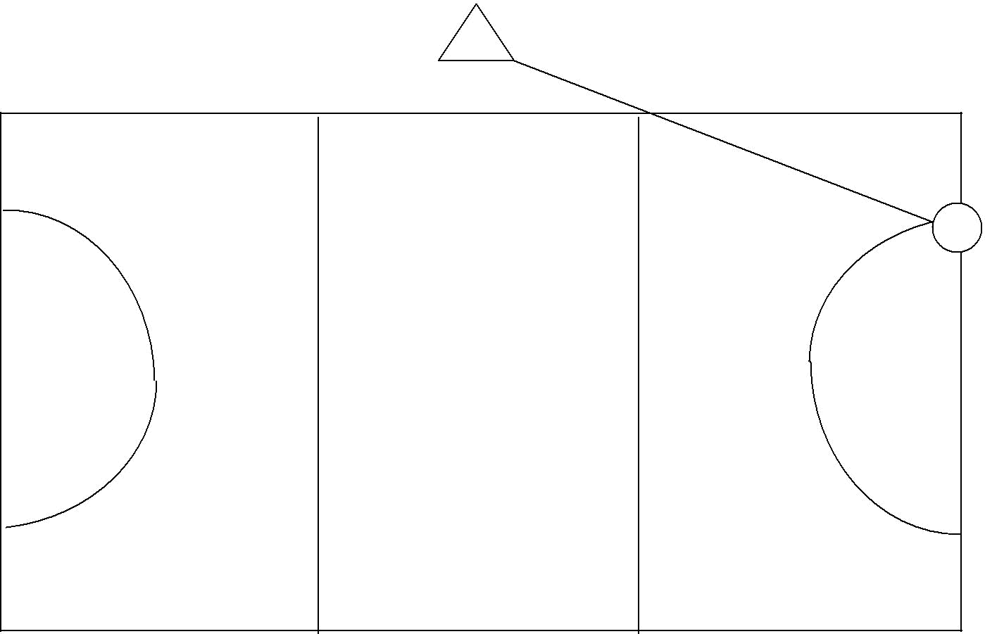

E
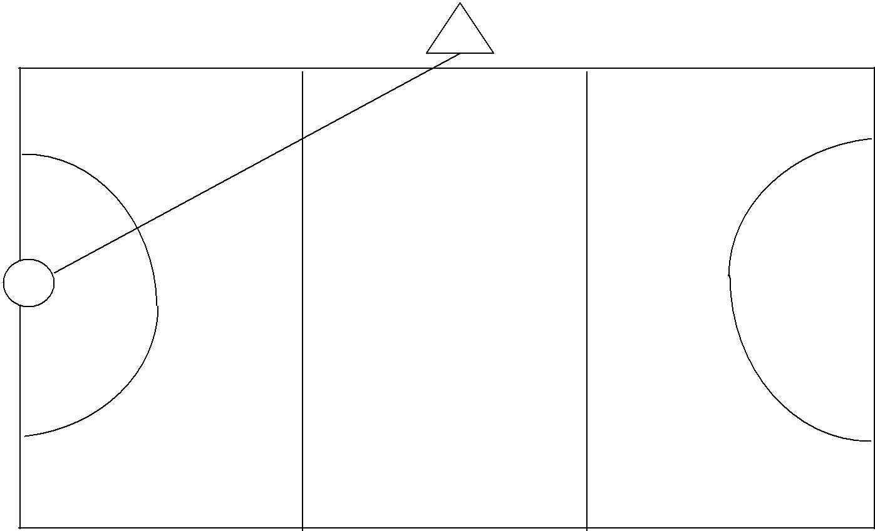

K

23
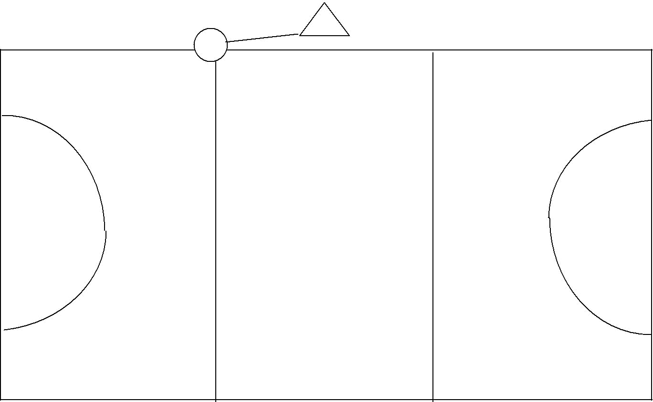
D
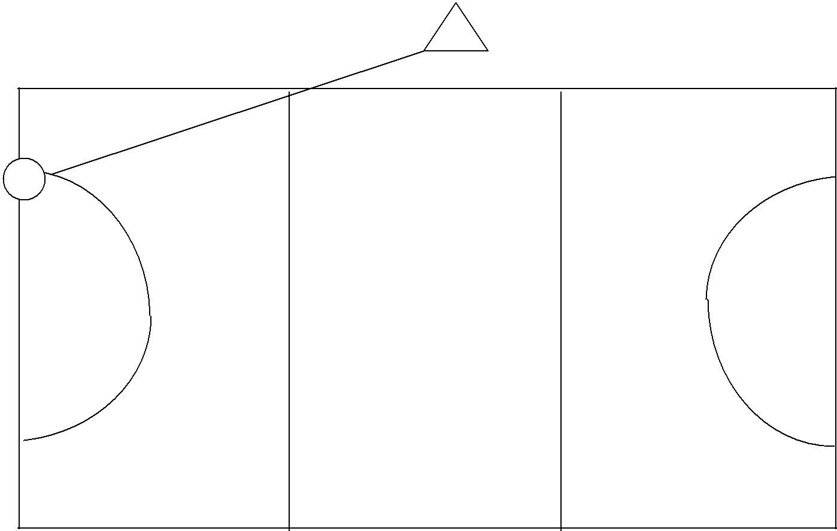

J

24
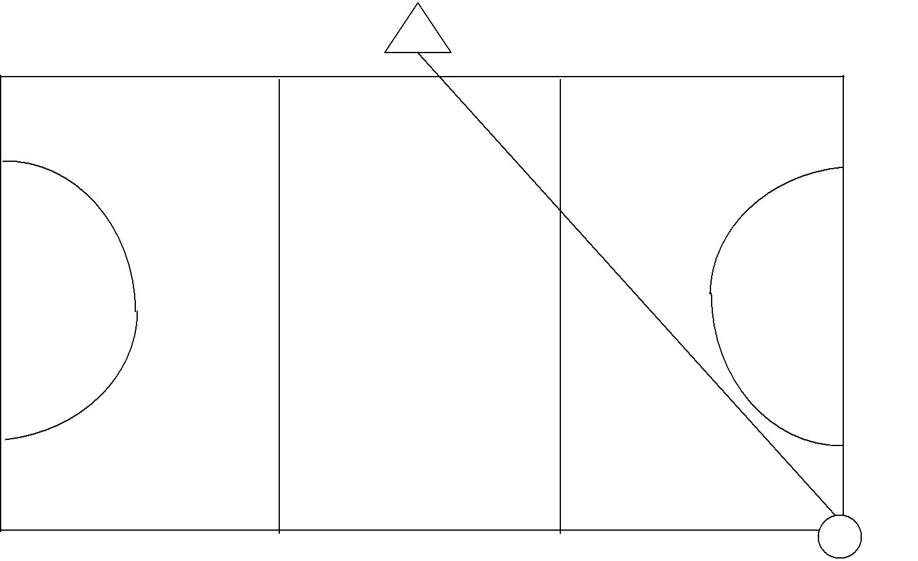

P
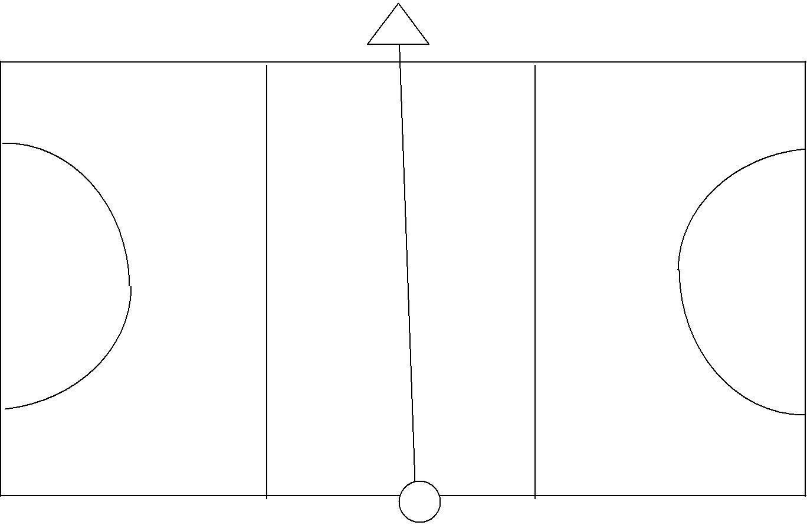

M

25
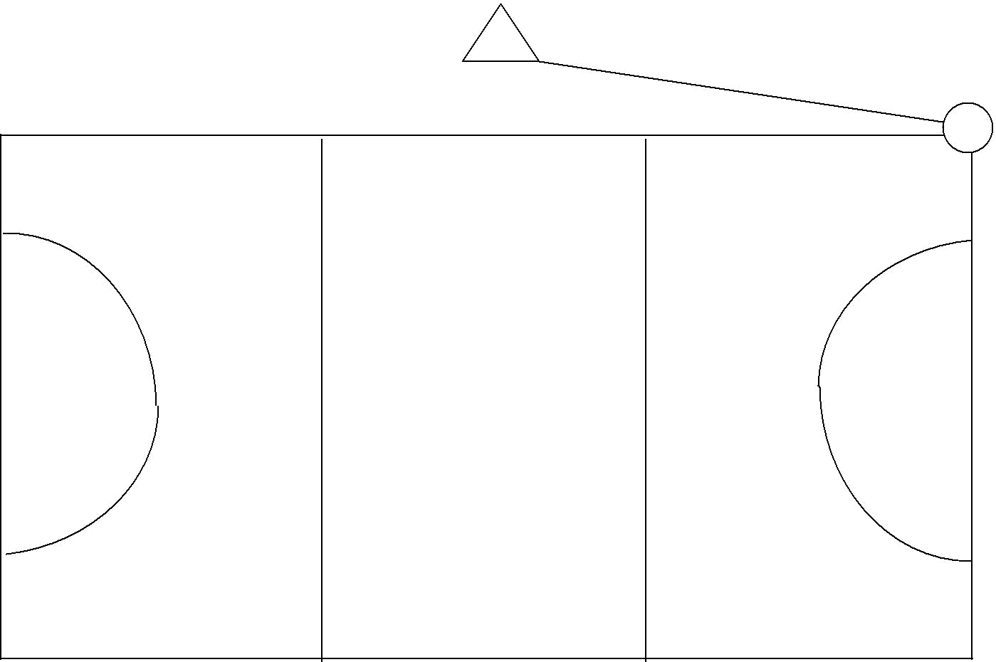
H
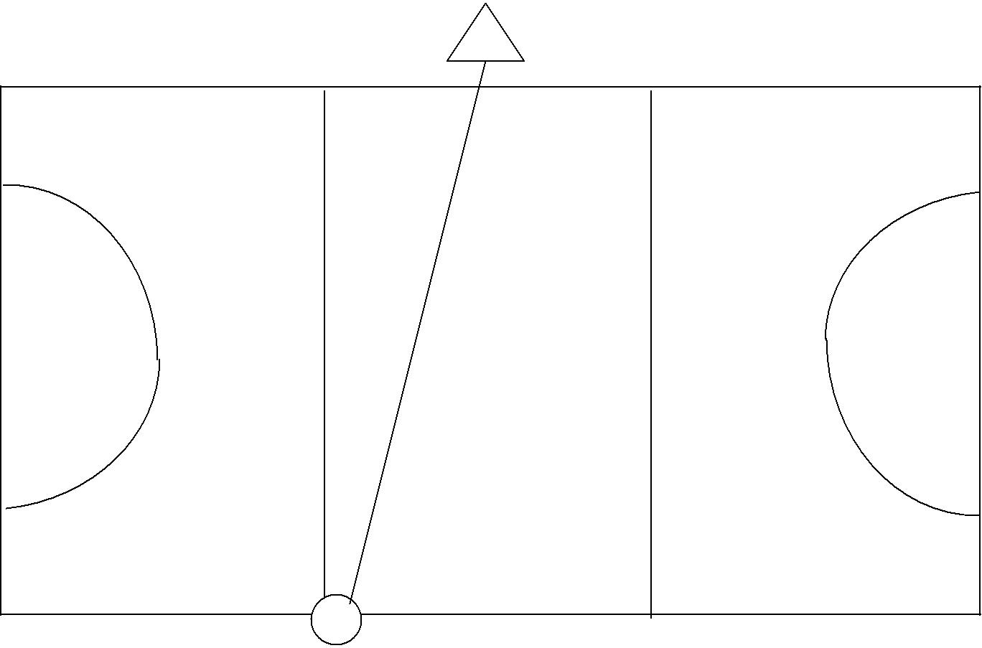

N

26
Netball Numbers – Courses

Resources:

- Netball court maps, 6 maps with sufficient copies of each map to have one per pair with a few left over. Each set of maps to be placed in separate box or bag.

- 14 cones or markers labelled with the code numbers as follows:

- 4 with number 1
- 4 with number 2
- 4 with number 3

- 2 with number 4

- Answer Sheet:

Map 1 = 14, Map 2 = 15, Map 3 = 11, Map 4 = 12, Map 5 = 13 Map 6 = 10

Preparation:

- Put out the cones on a netball court as per the diagram, taking care to position them accurately. Make a start triangle on the ground with red cones.

3 | 2 | 4
3
 |  | 2
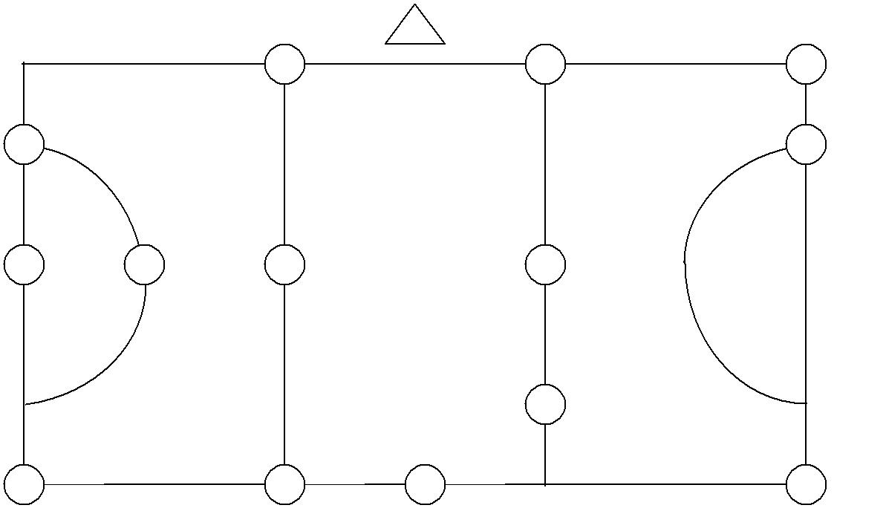
2 | 1 | 1 | 1

 |  |  | 2
1 | 4 | 3 | 3

The Session:

- The children should be in pairs

- Explain that the triangle on the map represents the start.

- Give child 1 the map of one of the courses, child 2 is responsible for adding up the total of the code numbers they find on the cones for the course they are doing.

27
(Map 4 – Cones values are 2+1+4+1+3+1= 12) Each child has a role either map reading or adding up.

- Give successive pairs different maps to start with, so that they don’t all follow each other.

- When a pair returns from a course with the correct answer give them the next map in the set, this time child 2 with the map and child 1 adding up. Swap roles each time they start a new course.

- Continue in this way until the time is up or everyone has completed all the maps.

D
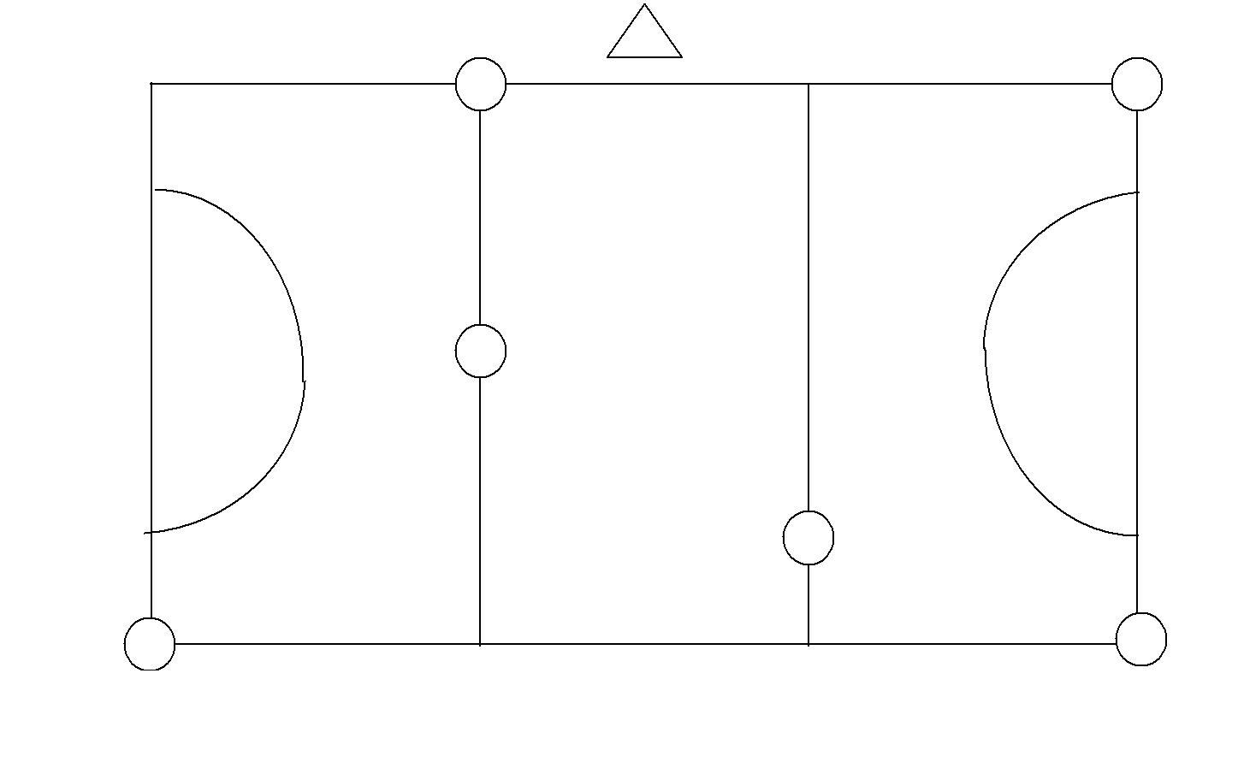
E

C

B | A

Map 1

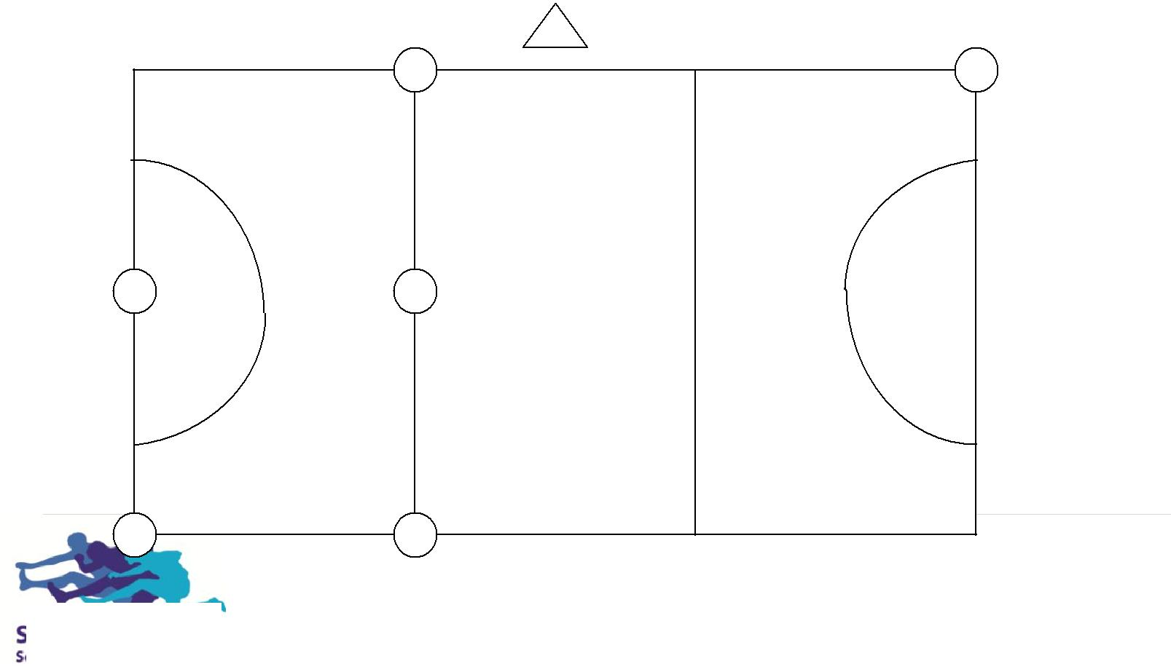

A
F

D

B

C

F |  | E

28
Map 2

B
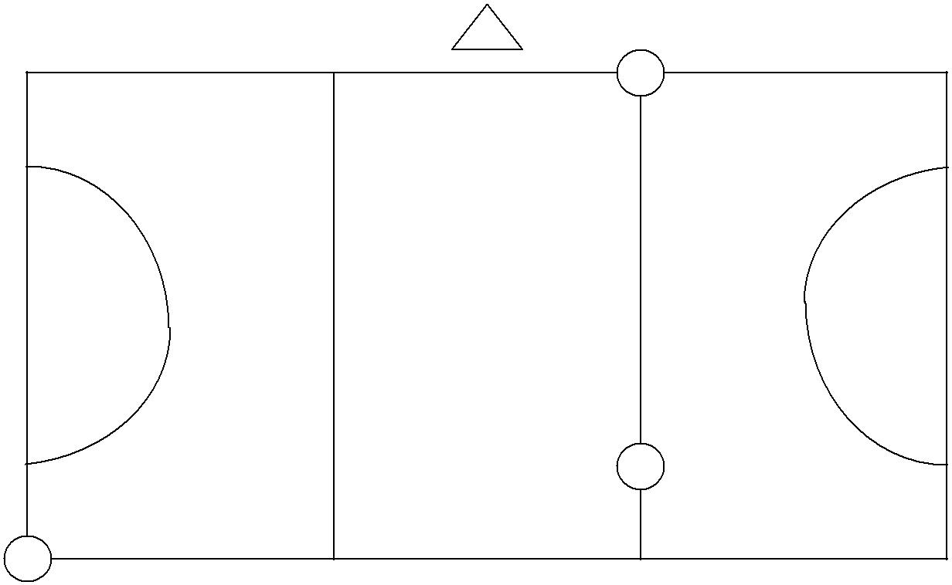

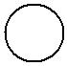 C

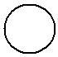 A

F | E

D

Map 3

E | F
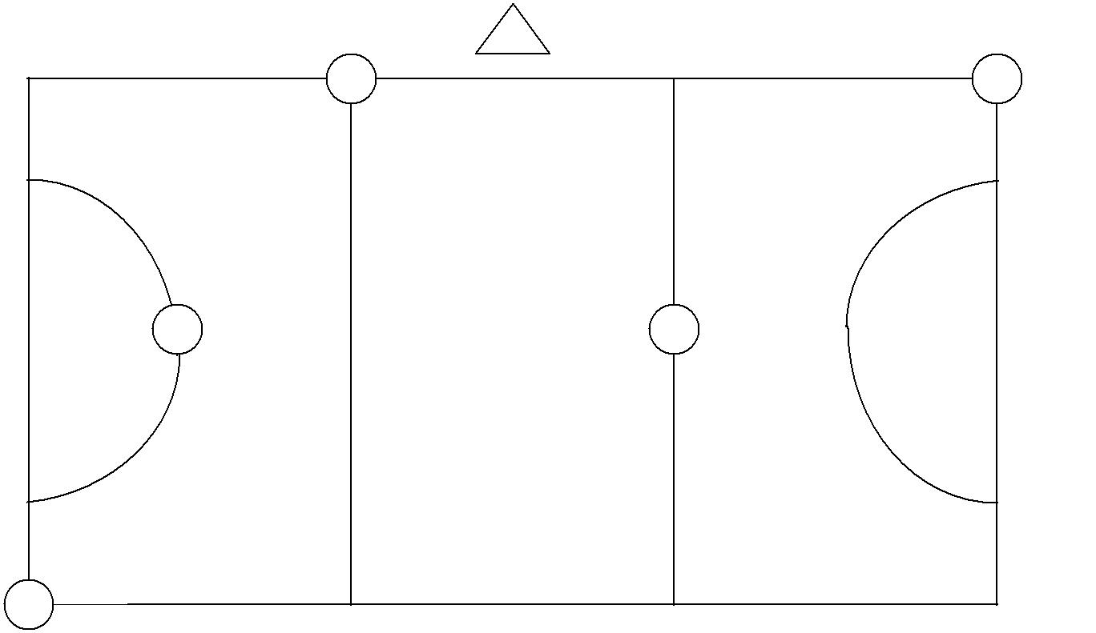

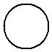 A

D | B

C

Map 4

29
A
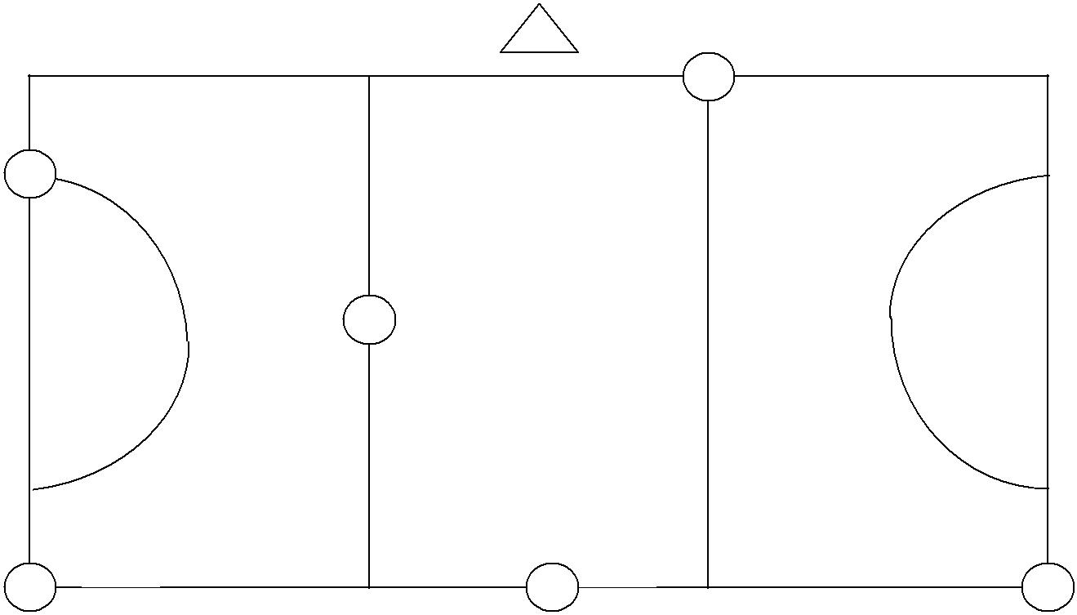

F

D

E | C | B

Map 5

E
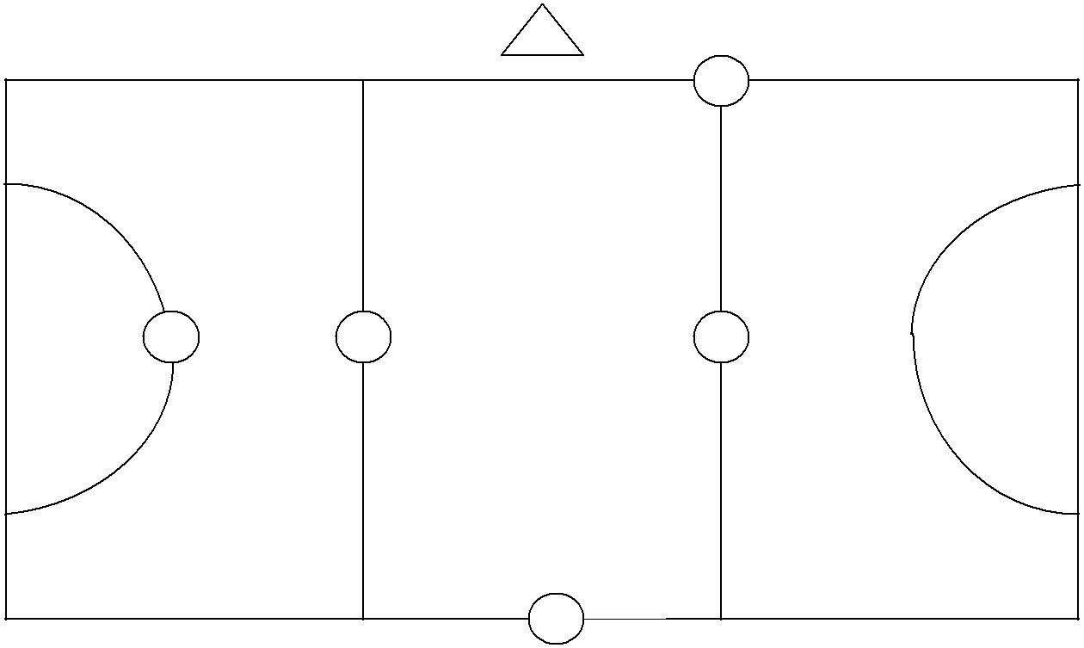

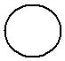 D

A | F | C

B

Map 6

30
What if you don’t have a Netball Court?!

Badminton Court adaptation.

(The answers are the same as the netball sessions!)

4 | 1
3 | 1 | 4
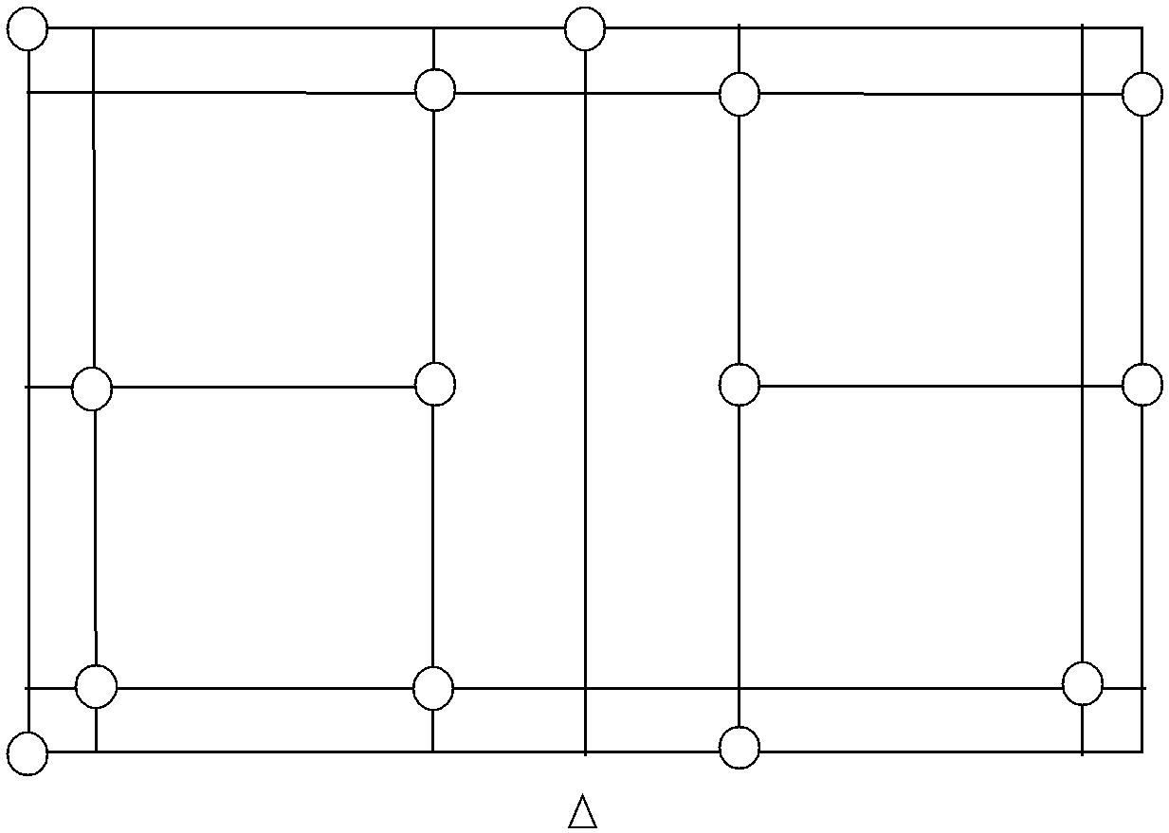

2
1 |  | 3 | 2

2 | 1 | 3
3 |  | 2
E |  | C
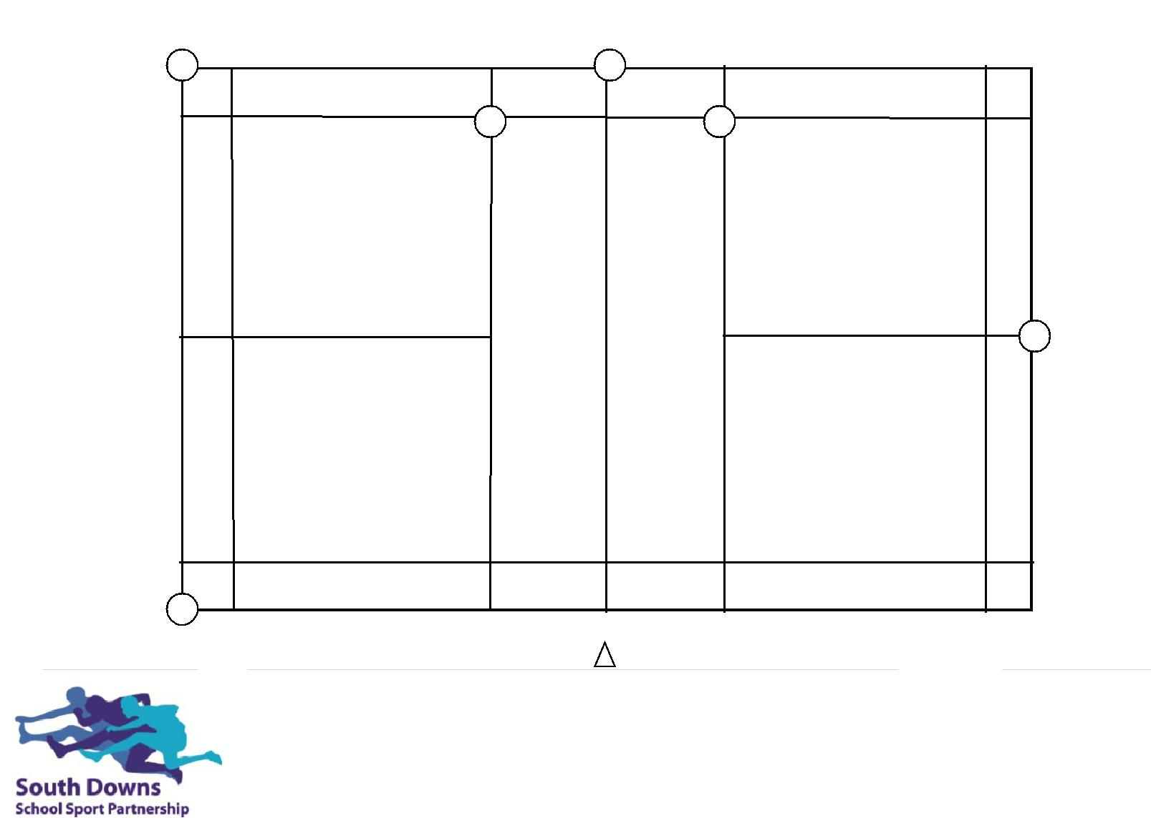

D | B

A

MAP 1
F
31
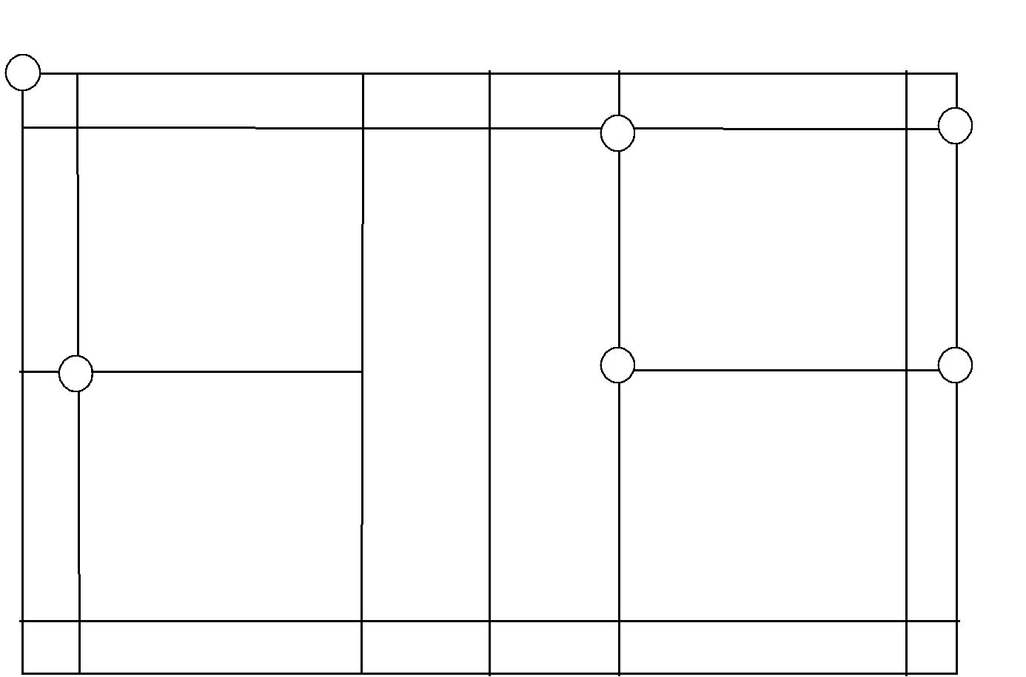
E

C

D

B

F |  | A
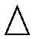

Map 2
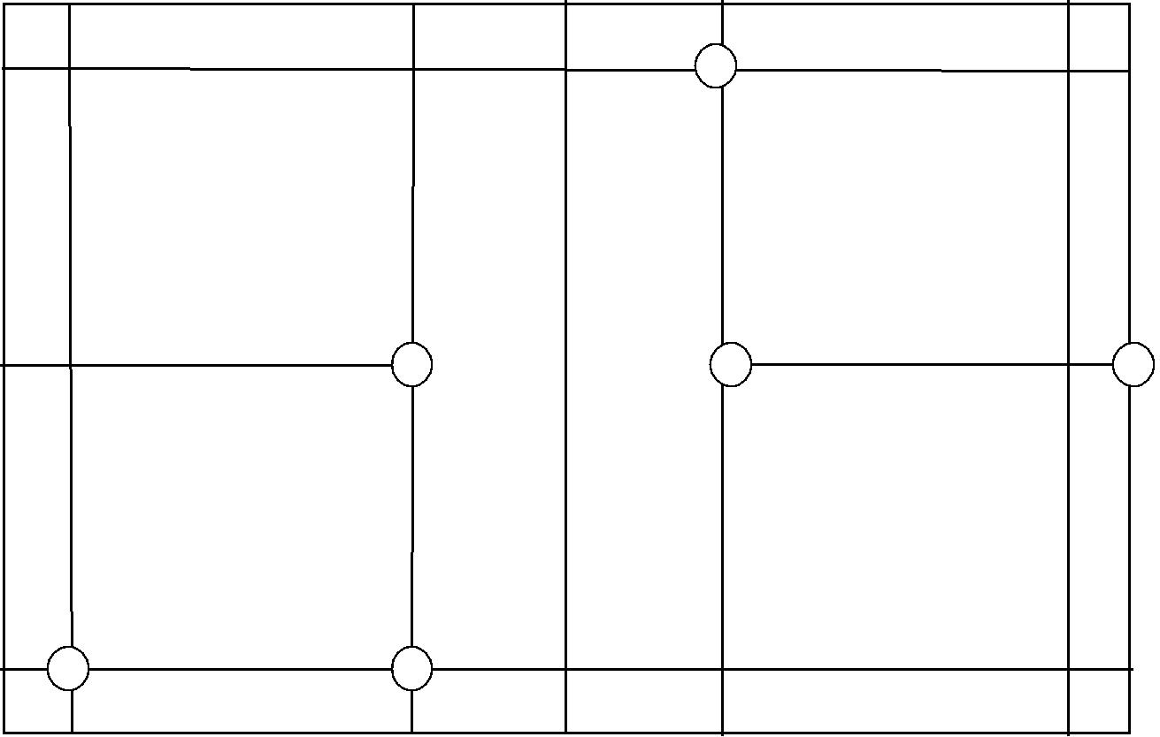

D

C

F

E

A |  | B
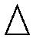

Map 3

32

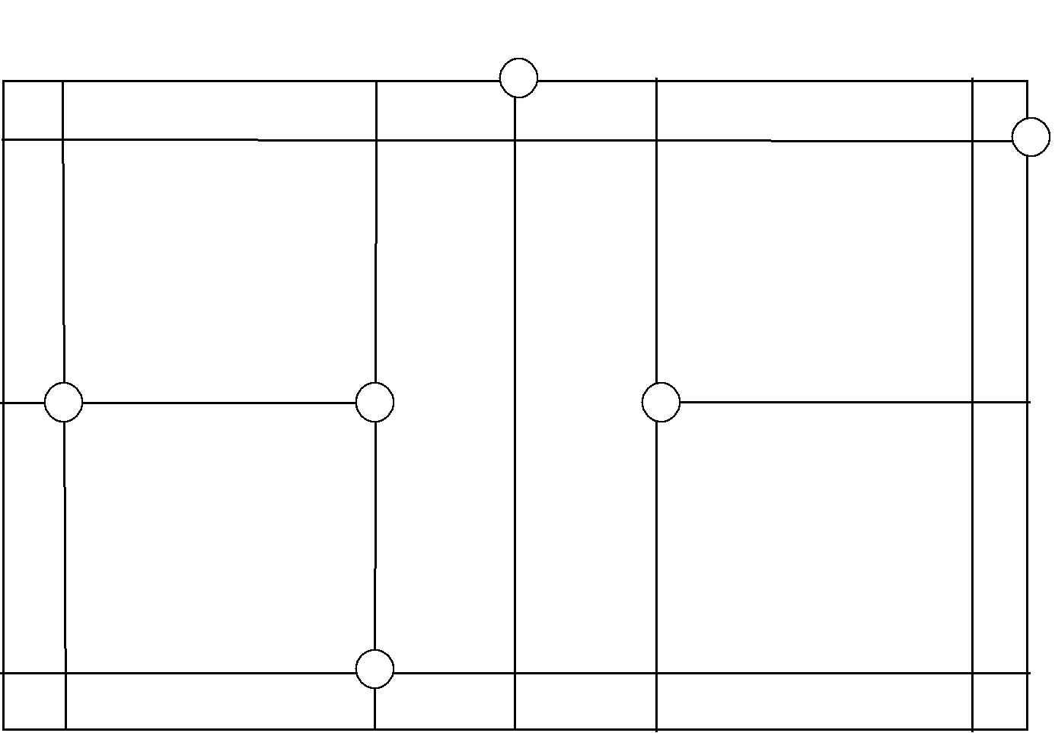
D

F

 |  | E
C |  | E

B

A
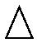

D
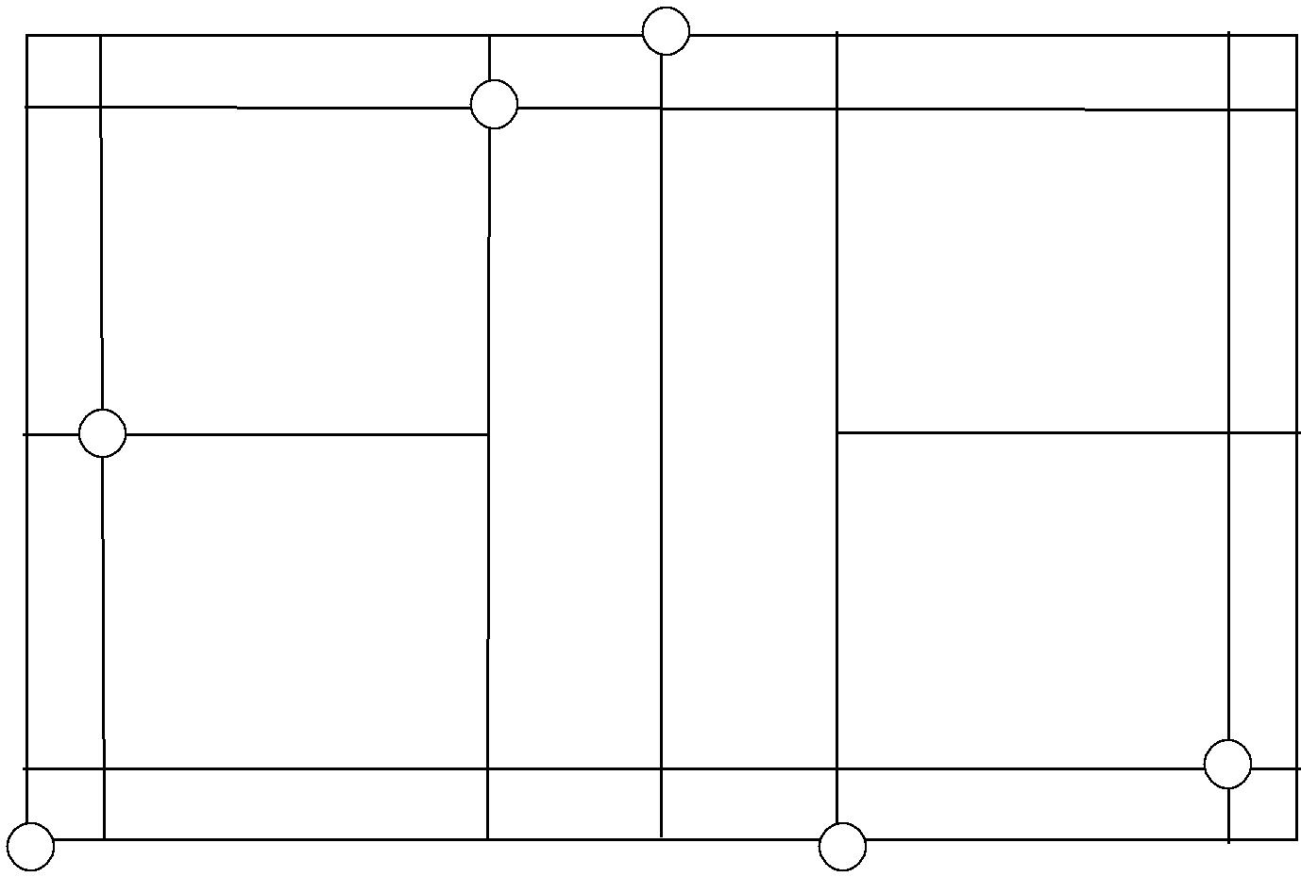

C

B

A F

Map 4

E

Map 5

33

C
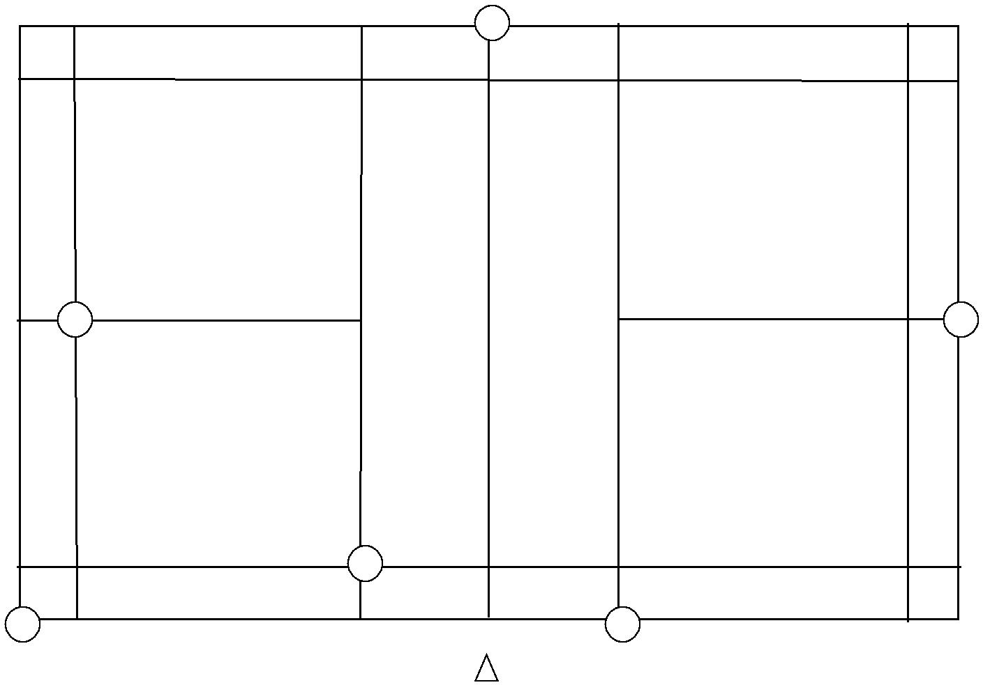

D |  | B

F

E | A
E | Map 6

34
Tennis Courts Courses

See Netball Numbers for full instructions.
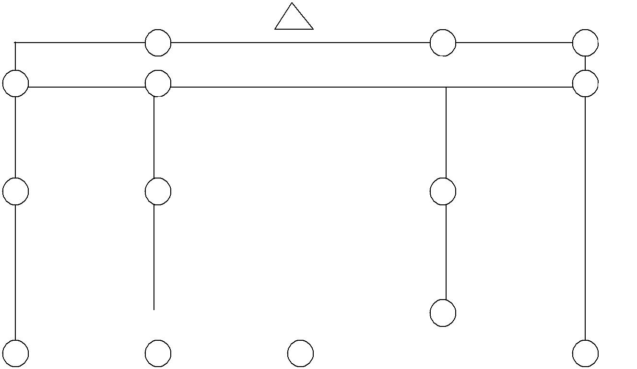

3 | 4

2
3 2

1

 | 2 |  |  |  |  |  |  |  |  |  |  | 1
 |  |  |  |  | 1
 |  |  |  |  |  |  |  |  |  |  |  | 2
 | 1
 | 1 |  |  |  |  |  |  |  |  |  |  |  |  |  |  | 3
 | 4 |  |  |  |  |  | 3 |  |  |  |  |  |  |  |  | 3
14 Cones required marked as follows: |  |  |  |  |  |  | Answers:
1. | 4 cones |  |  |  |  |  | Map 1 =14
2. | 4 cones
3. | 4 cones |  |  |  |  |  | Map 2 = 15
4. | 2 cones
 |  |  |  |  |  |  | Map 3 |  | = 11
 |  |  |  |  |  |  | Map 4 |  | = 12
 |  |  |  |  |  |  | Map 5 |  | =13
 |  |  |  |  |  |  | Map 6 |  | = 10

35
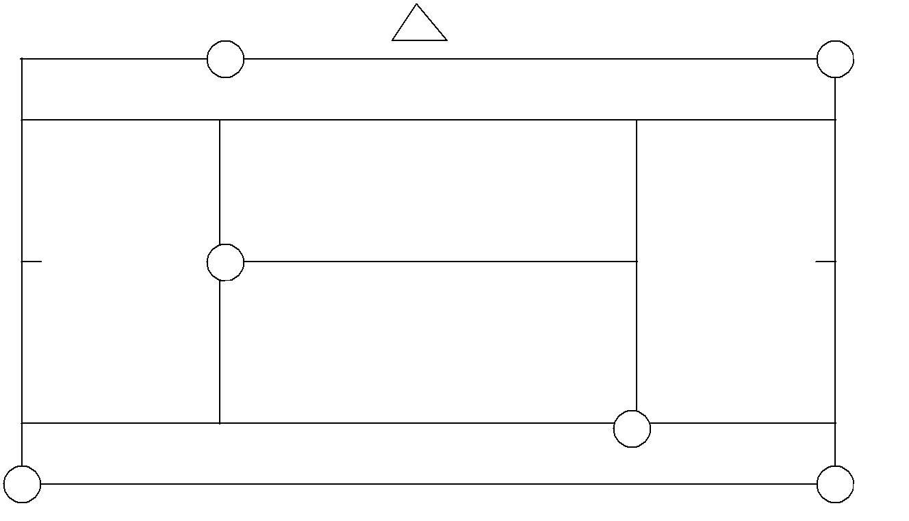
MAP 1

D | E

 | C
 | A
B | F
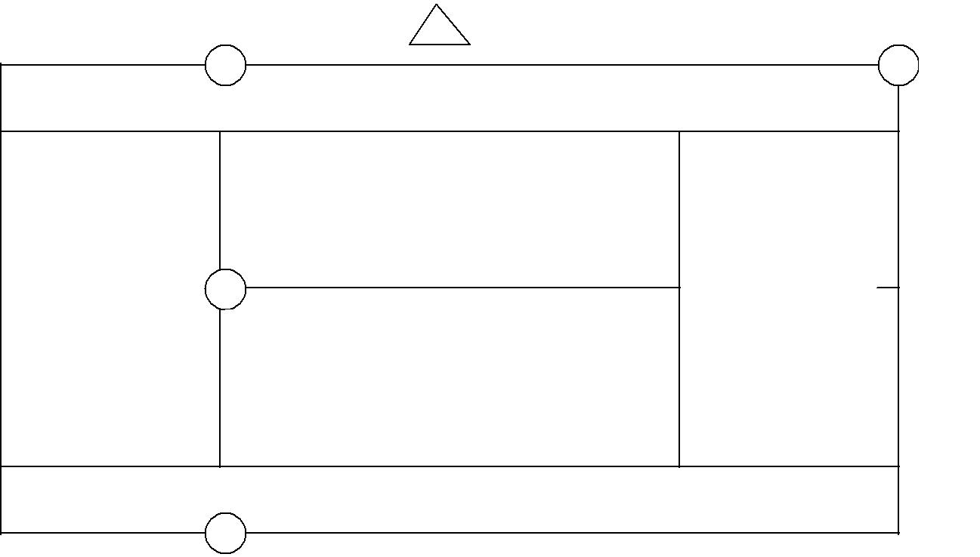

MAP 2

A | D

B 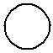

C

F 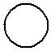

E

36
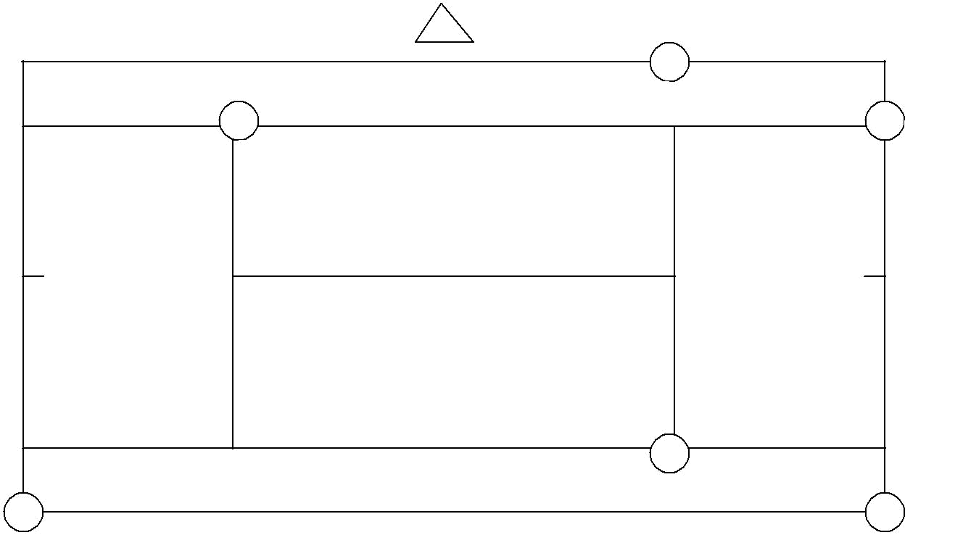
MAP 3

B
C
A

 | E
F | D
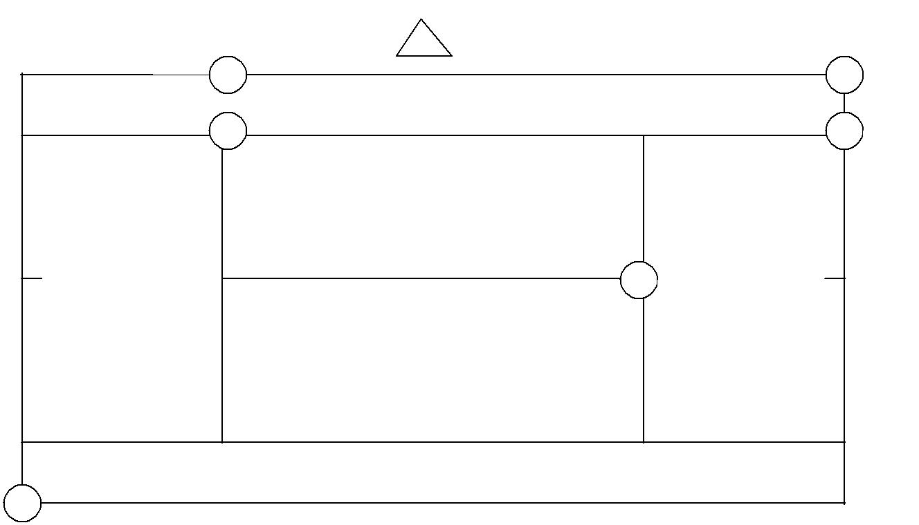

MAP 4

E | F

A

D

B

C

37
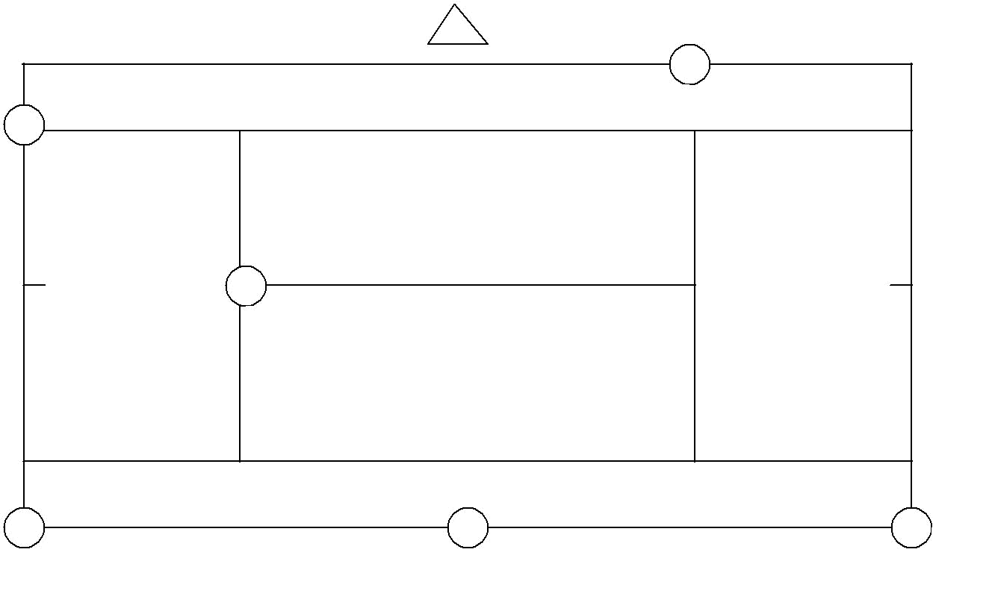
MAP 5
A
F

D

E |  | B
 | C | B
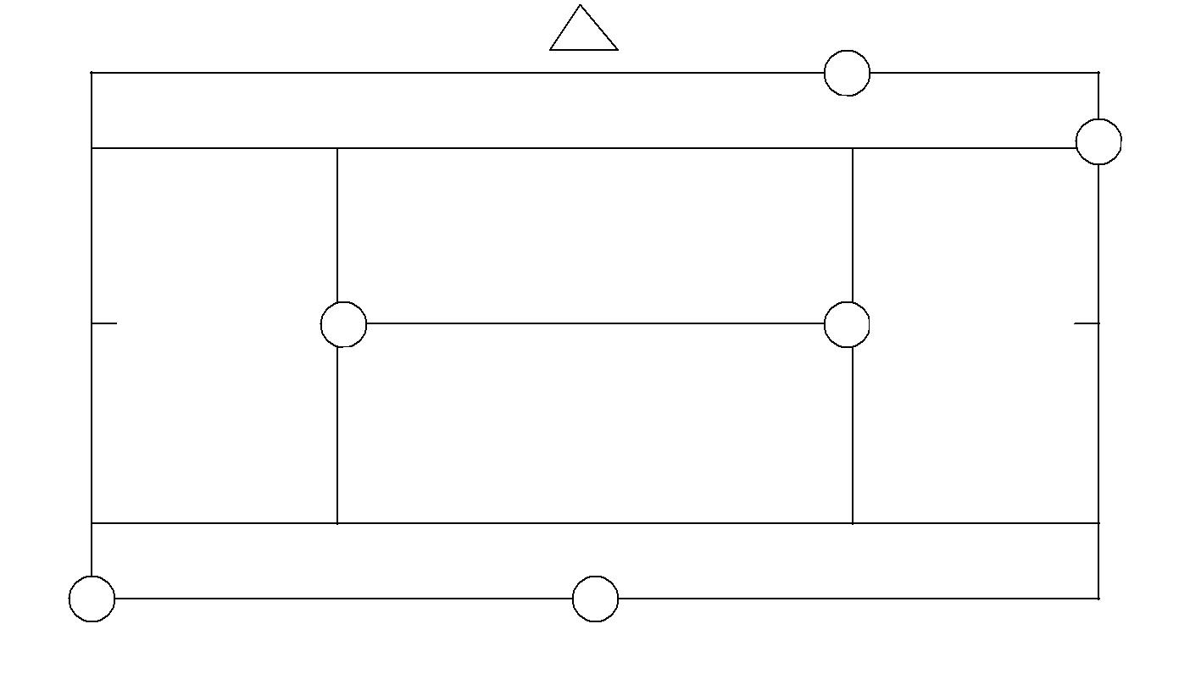

MAP 6

E

D

C

F

A

B

38
Tennis Courts Star Exercise

See Netball Numbers Stars for full instructions

3
3 | 2
3 | 1 | 4  Answer Sheet  ( The value given to each letter)  A,G,F,L = 1  B,C,E,K = 2  D,J,M,P = 3  H,N = 4
 |  | 2
2
1 | 1 | 2
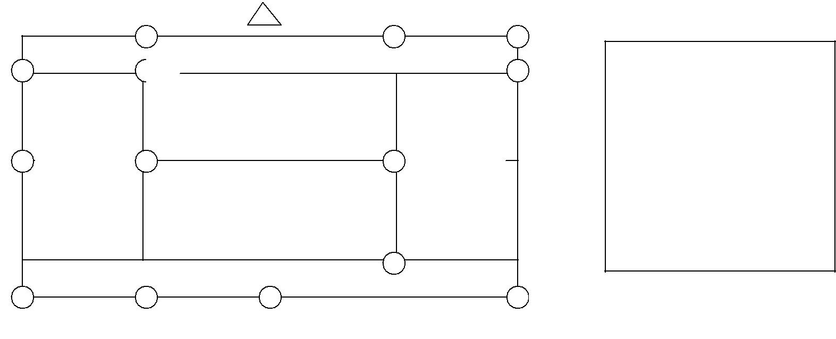

1 |  |  | 2
 |  | 3 |  | 3
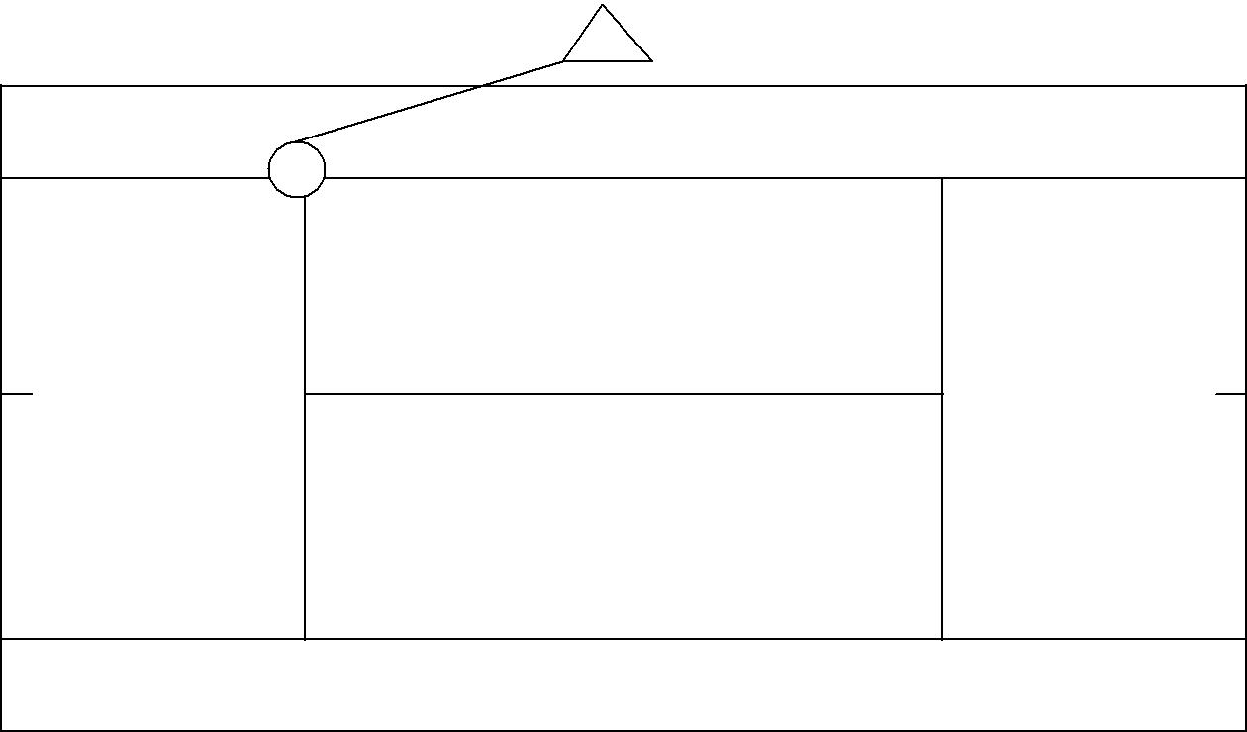
4

G

39
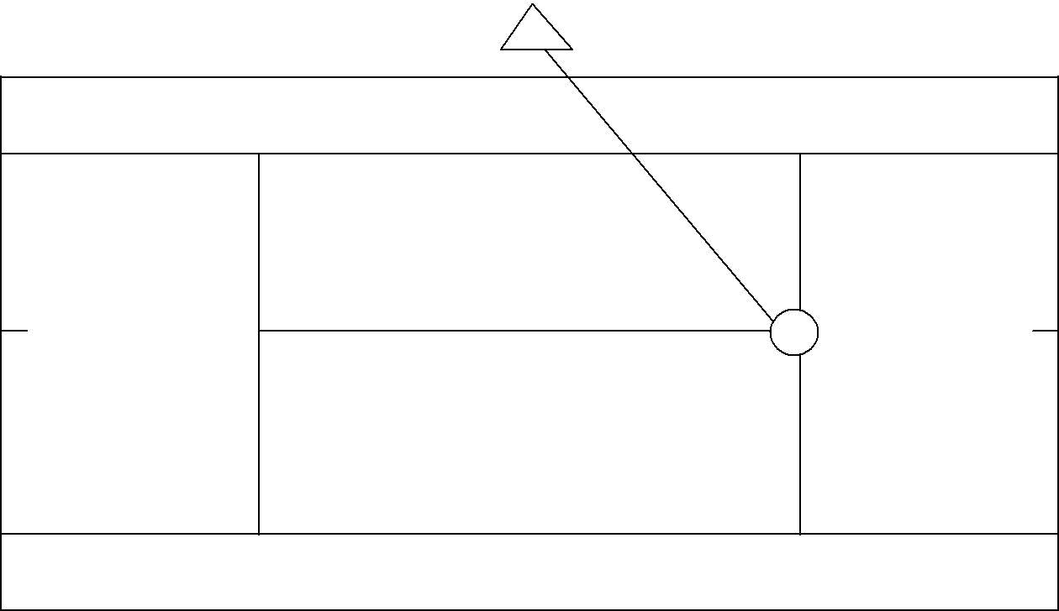
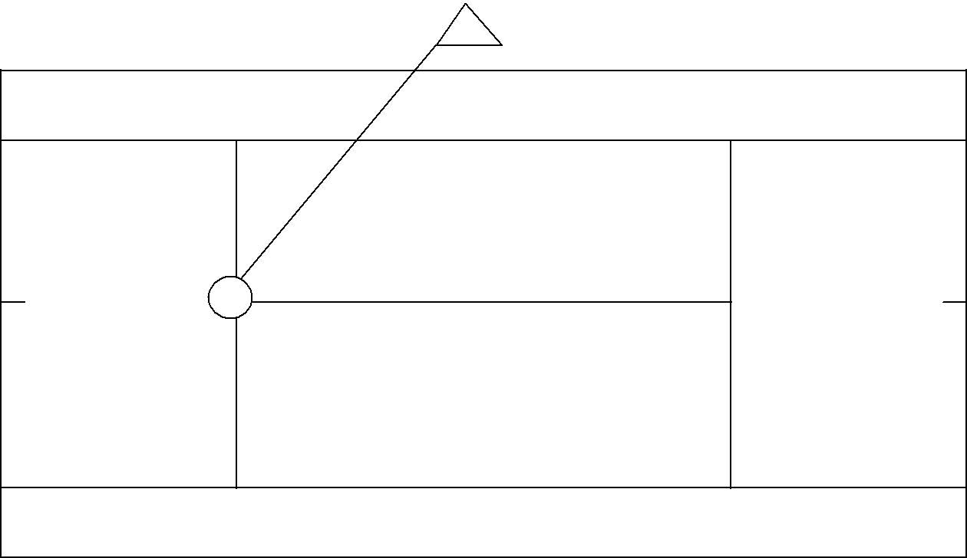

A

F

40
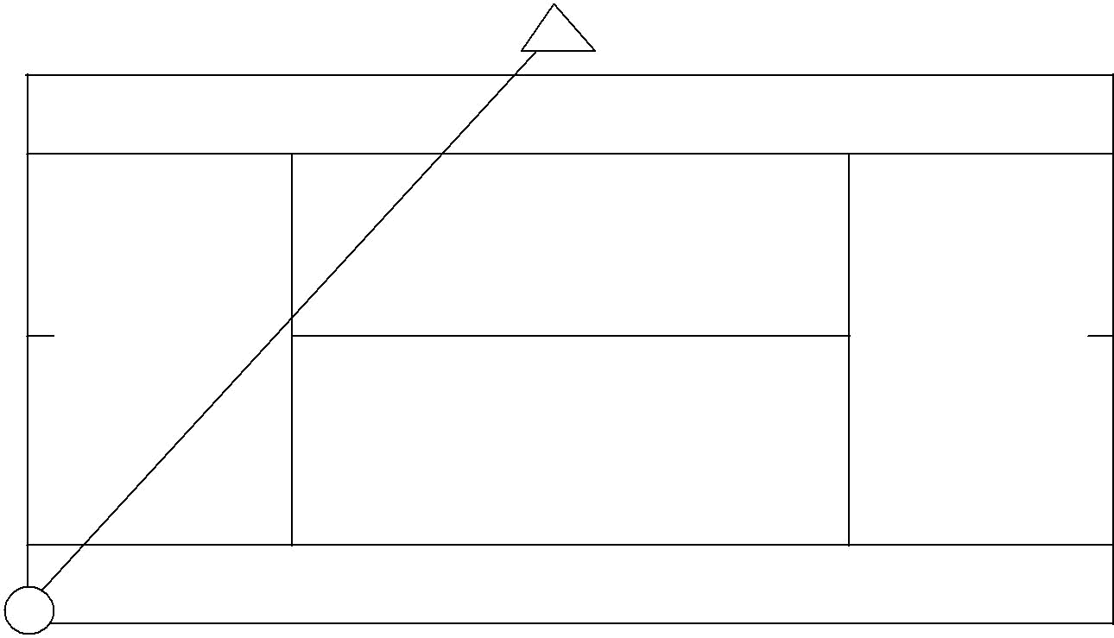

L

B
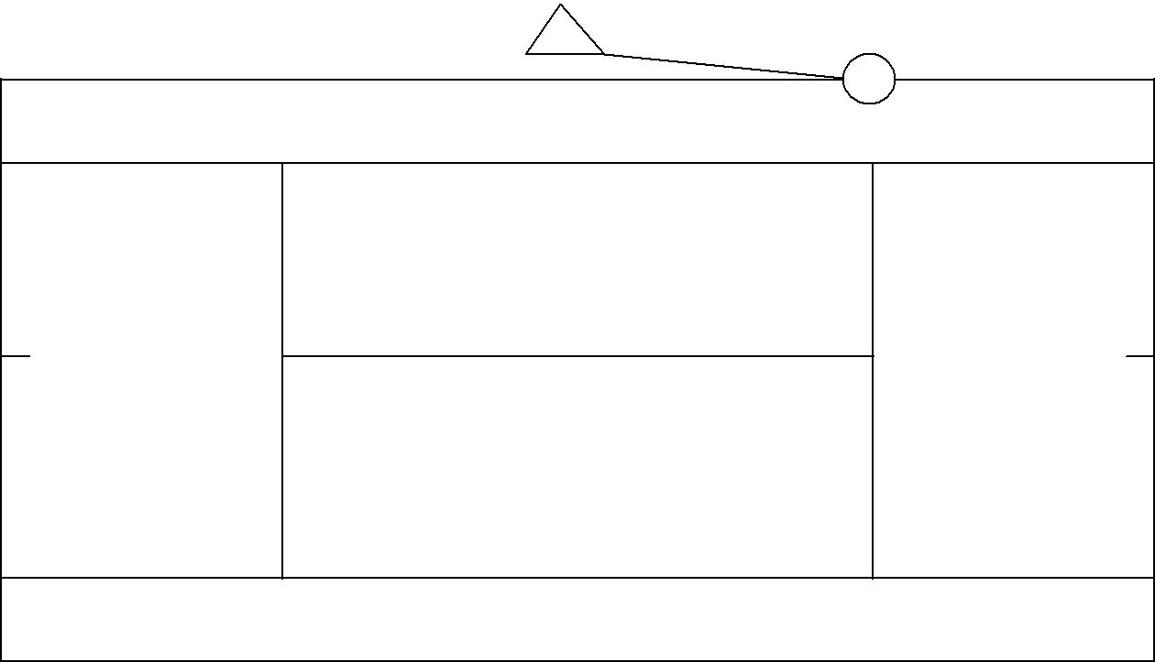

41
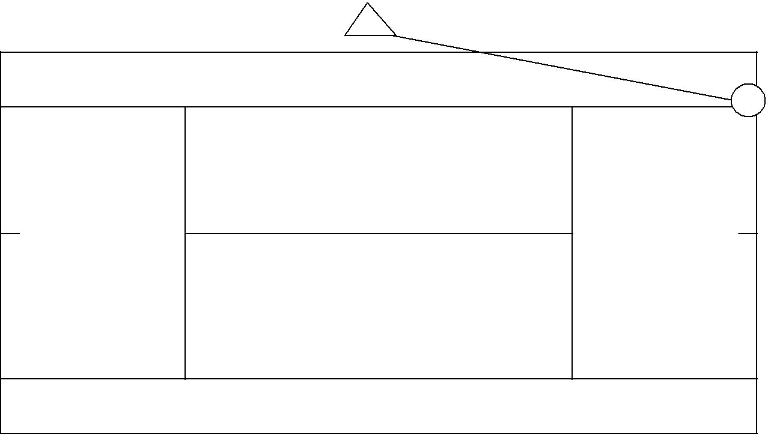

C
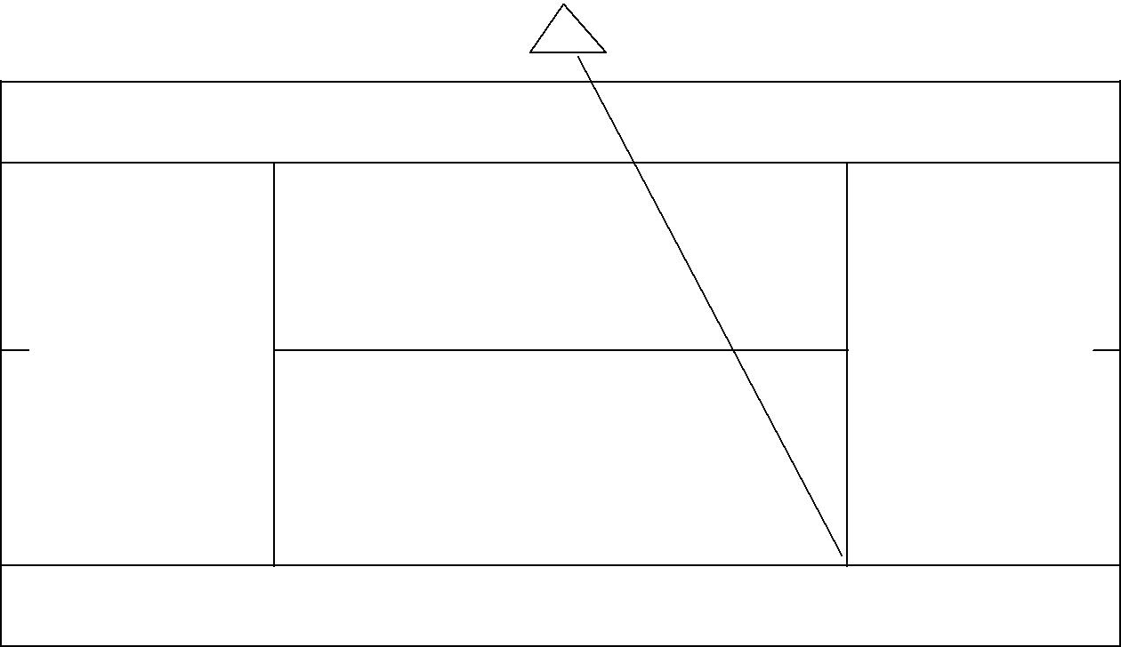

E

42
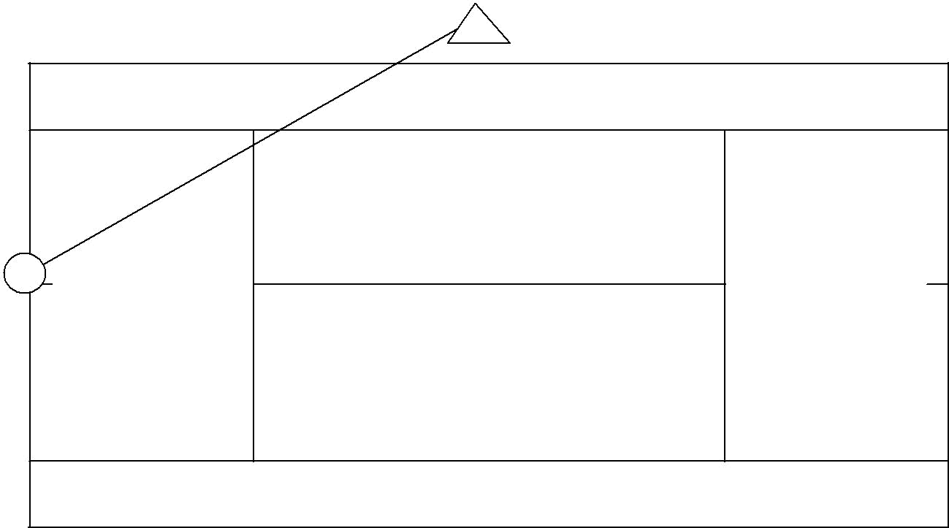

K

D
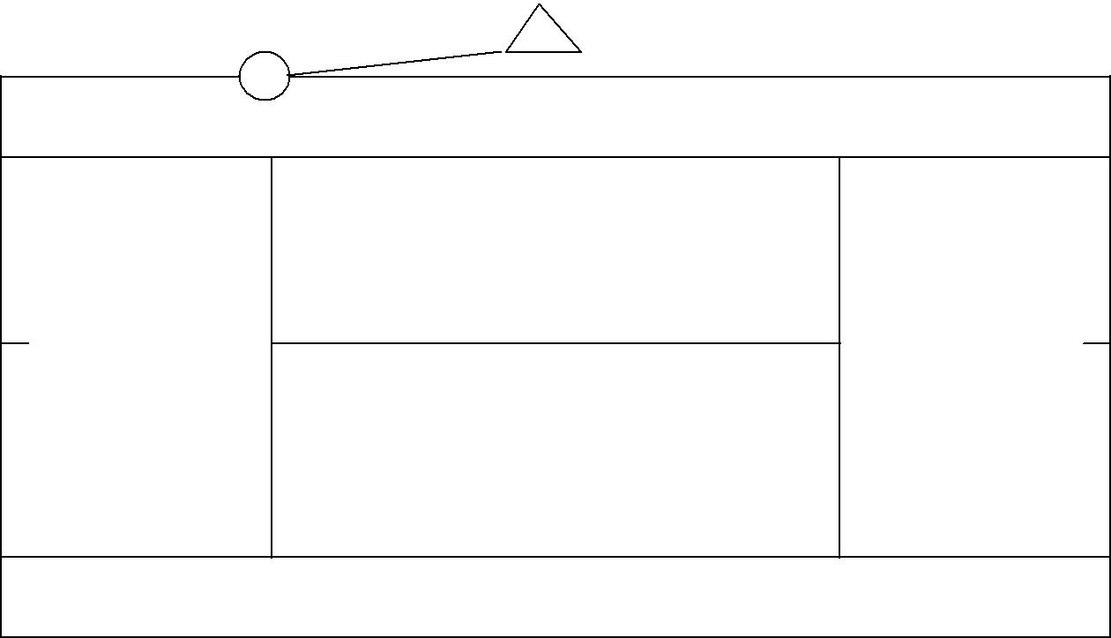

43
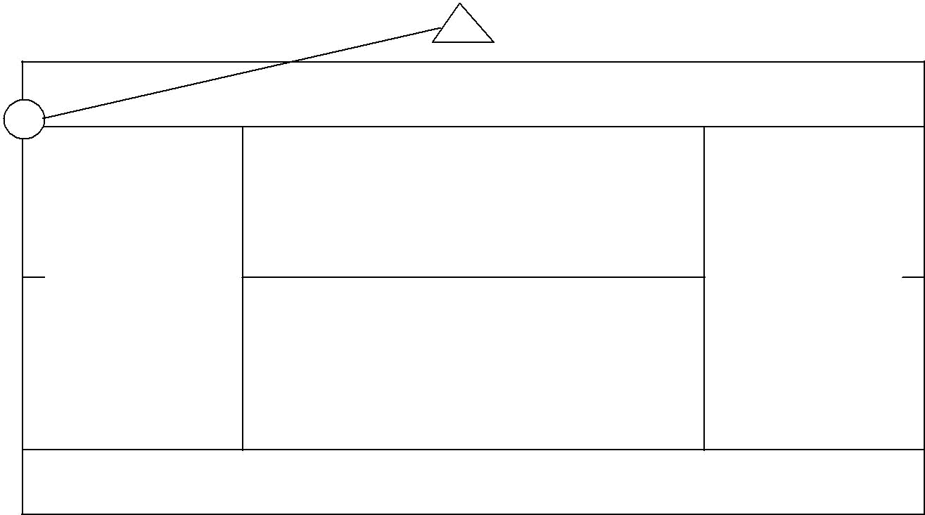

J
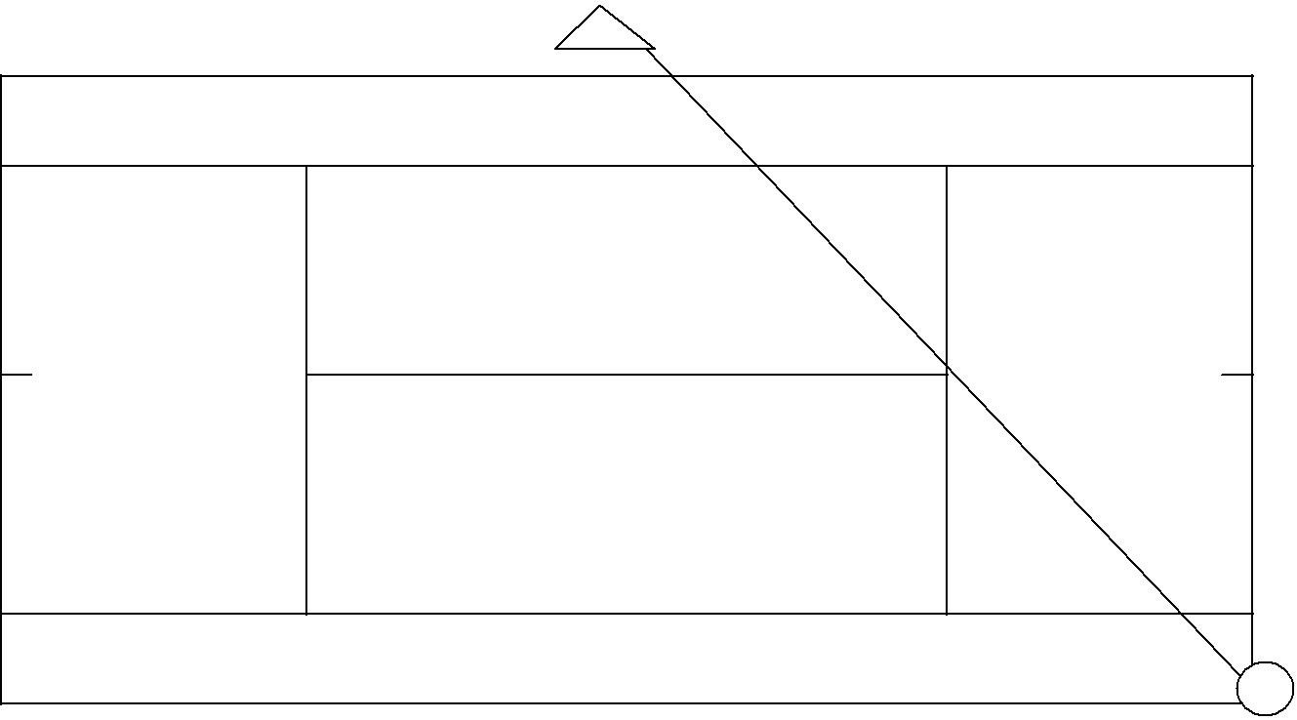

M

44
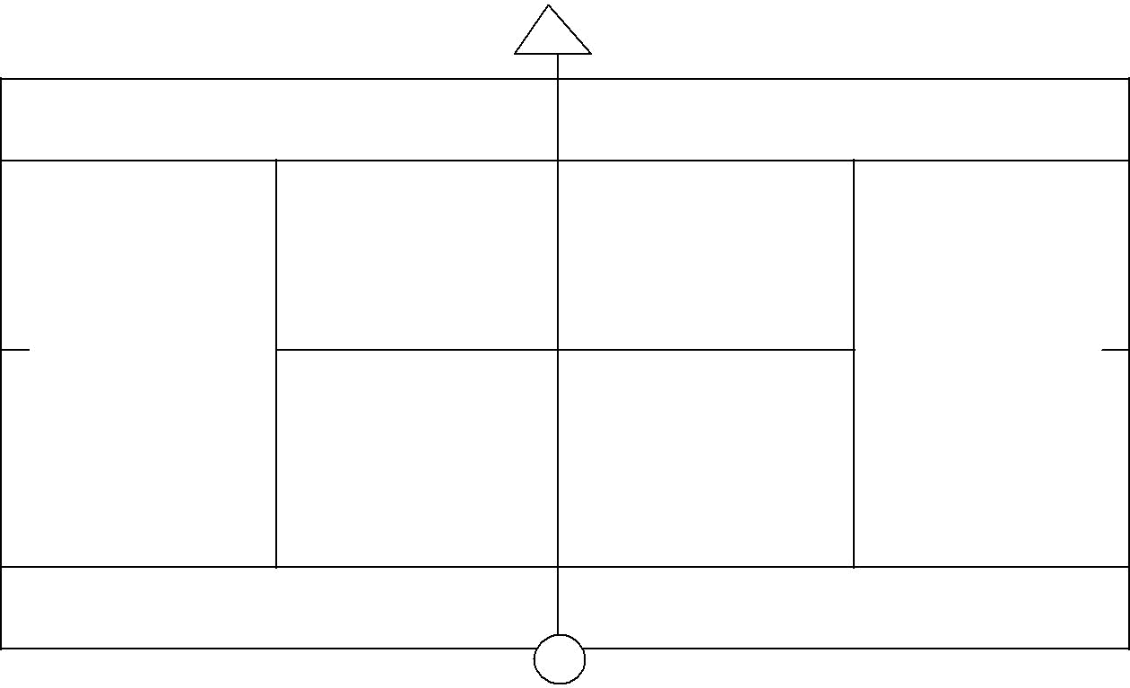

P
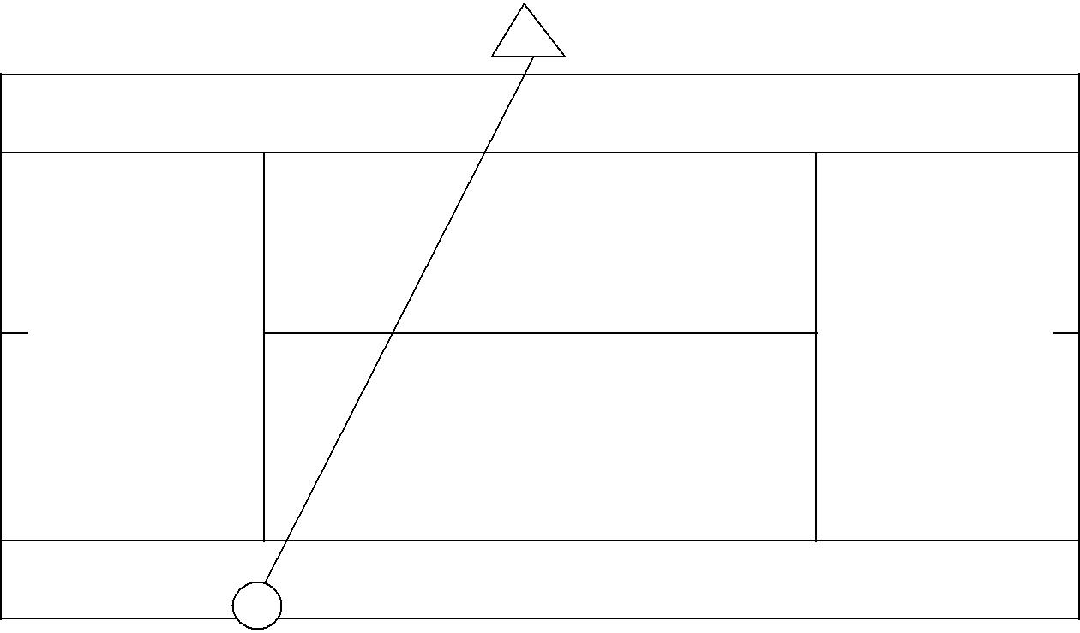

H

45
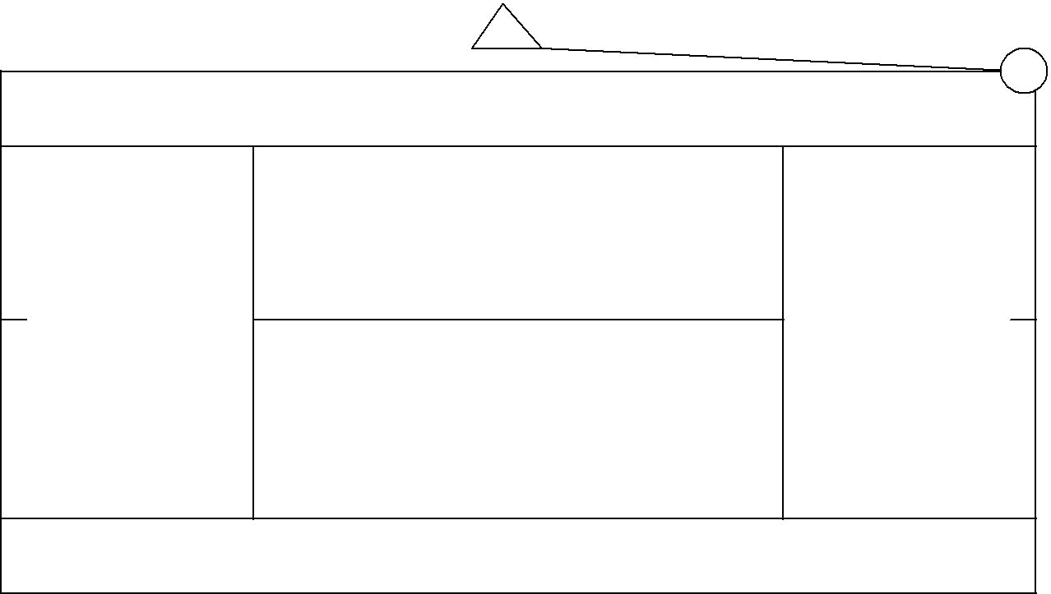

N

46

