



Berkshire Orienteers
and the
South Central Orienteering Association
and the
British Schools Orienteering Association

present the

BRITISH SCHOOLS ORIENTEERING CHAMPIONSHIPS 2019

Sunday 17th November 2019

BLACK PARK, SLOUGH, SL3 6DS

TRAINING DAY

Saturday 16th November 2019

LANGLEY PARK, SLOUGH, SL0 0LS

Officials
Overall Organiser: Eric Harper
Entries and Enquiries: Melanie Elkington. bsoasecretary@gmail.com
Sunday: Planner – Robin Bishop; Organiser – Eric Harper; Controller – Jim Prowting

Acknowledgements
Many thanks to the Buckinghamshire County Council Country Parks team for allowing us to use Black and Langley Parks.

Final Details

Getting there

Both parks are close to each other so the general travel details are the same (see map below). Both Black Park and Langley Park are off the A412, Slough to Denham Road. Both parks are signed off the road, which is a dual carriageway near the parks, so follow the country park signs. Langley Park is only accessible when travelling W (from Denham to Slough) on the A412. If you are coming from Slough on the A412 you will need to go to the roundabout at Iver Heath (by the Crooked Billet pub) and then go back on the A412 towards Slough. The turn off to Langley Park is approximately 300 metres down the A412 after the roundabout.

Black Park is accessible from both carriageways on the A412, but when leaving Black Park and joining the A412 the junction has changed and you must turn left onto the A412. If you want to go south you will have to go to the Crooked Billet roundabout and retrace your steps.

FROM the North

It is best to exit at the M40, junction 1 and take the A412 South towards Slough. If you are travelling along the M25 from the North take the turn off onto the M40 and then go East to junction 1 of the M40.

FROM the West

The M4 will be shut between junctions 8/9 (Maidenhead) and junction 6 (Slough) for the whole weekend for the demolition of bridges on the motorway.

When you leave the M4 at junction 8/9 take the A308(M) and then turn right onto A308 to Windsor. When you arrive in Windsor take the A332 towards Slough and stay on this until you come to the junction of the A322 and A412. Then go on the A412 towards Black and Langley Parks.

The closure of the motorway is likely to lead up to a big build up of traffic in the Slough area so please allow plenty of time to get to the event.

FROM the South and South East.

Leave the M4 at junction 5 and head W on the A4 towards Slough and turn right onto the A412.

It is possible that the closure of the motorway W from junction 6 might result in tailbacks to junction 5 so please allow extra time.
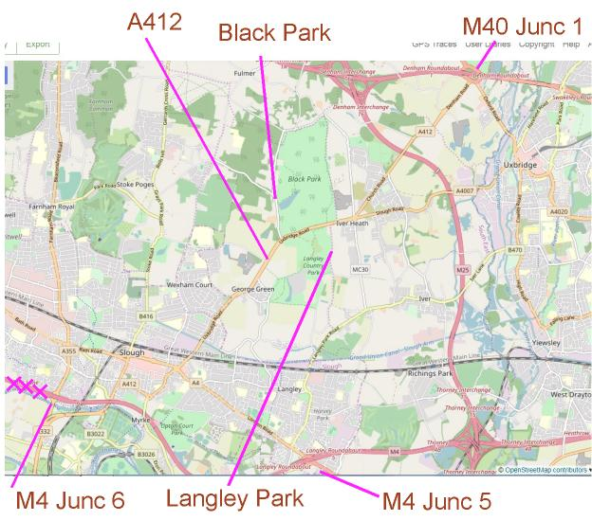

Cancellation
It is very unlikely that we will need to cancel any of these events, but if you are concerned about cancellation please check websites www.bsoa.org / www.bko.org.uk or telephone the Organiser on 0118 9482934 / 07954 391237 before 9pm.
Safety
Whilst we will do everything we can to make this event as safe as possible, competitors do take part at their own risk.
- It is your responsibility to ensure that they are properly prepared for the event, and clothed in a manner suitable for the conditions on the day.
- No shorts. In recent years the woods have become badly affected by the spread of brambles - full leg protection is essential. Anyone without full leg cover will not be allowed to start.
- It is compulsory for whistles to be carried whatever the weather.
- In the event of bad weather, cagoules may be compulsory – please come prepared. Notices will be put up in the car park, at enquiries, and en-route to the start if they are required.
- Both parks are very popular with the public, both on foot and using bikes. Please take care on some of the narrow paths

We will, of course, be monitoring the time that runners spend in the forest, but please help us by letting Enquiries know if you are concerned about one of your team.

Photographs
As usual, Ray Barnes will be taking photographs in several places at BSOC so that they can be placed on the BSOA web site. There will be no names or ages attached. If you wish to use any of the photo's then please email bsoasecretary@gmail.com to ask for permission - include the photo’s number. We will email you a higher resolution photo and ask that Ray Barnes be credited.

Punching
Electronic SI control boxes will be mounted on a stake, along with an orienteering kite and the control code.
IT IS THE COMPETITOR’S RESPONSIBILITY TO REGISTER ACCURATELY AND COMPLETELY AT ALL CONTROLS.
Rulings on mispunching, etc., possibly due to “dibbing” too quickly, have been strictly applied at a number of high-profile events and these Championships are no different.
There are many controls in the forest, and runners can expect to see some that are not on their course. Please make sure control codes are checked carefully. If, however, a competitor does mistakenly “dib” a control that is not theirs this will not matter as long as they also “dib” at all the right control, in the right order.

Maps
All maps for the weekend’s events will be printed on A4 waterproof paper.
Black Park : Scale 1:10000.
Langley Park : Scale 1:5000
Both maps have been updated by Katy Stubbs, BKO
Control Descriptions
Written control descriptions for the championships will be on the front of the map.
Loose written control descriptions for the championships will be available in the start lanes.
Trophies
If your school has any of the trophies from last year please return them to Enquiries on Sunday.

BRITISH SCHOOLS ORIENTEERING CHAMPIONSHIPS 2019
Black Park, Slough, Sunday 17th November
Postcode SL3 6DS Grid Ref TQ005832

Below is map of the areas of Black Park that you are permitted to access before and during the competition. All the immediate area around the lake within the thick purple can be accessed at all times. Please do not go outside this area until after the competition has finished.
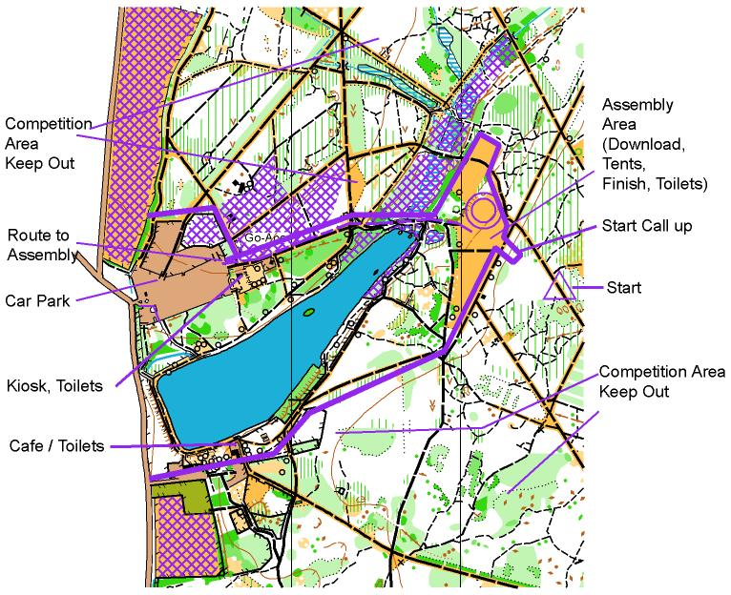

Car Park

There will be a coned area in the middle of the car park that has been reserved for us. This is primarily to ensure that the coaches have reserved parking. Please follow instructions of the marshals. Don’t forget to pay the parking charge. Exit the car park to go the assembly at the East end.

Assembly

The route to assembly, approx 450m, will be signed from the eastern end of the car park. At the car park end there is a kiosk selling food and there are also toilets. Please do not deviate from the marked route to the North as you will be entering the competition area if you do.

The assembly area is a grassy area that will include the Enquiries, Finish, Download, Portaloos, First Aid and a mobile catering van. There should be ample space for club tents.

Toilets
There are toilets near the car park and at the café in the park as well as portaloos in assembly.
Traders
There is a café in Black Park at the South side of the lake, a kiosk near the car park and mobile catering in assembly
Enquiries
A responsible adult from each school needs to register at Enquiries which is in assembly. Here you will be able to collect a school package consisting of number bibs, safety pins and participation certificates for each child. These will also be available to be picked up at the training day at Langley Park.
There is no entry on the day. However, if illness or injury requires substitution of runners please enter the new names on the spare form provided in your school bag and hand it in to Enquiries. This should also include cases where only one of a registered pair now intends to compete.
The pairs will have one bib with a black number on it and one bib with a black number with a red stripe, please use only the black number bib if one member of a pair drops out. The Red line will be put on the number without the line at Enquiries.
If there are any mistakes or changes needed to an entrant's class then this MUST be done before the event by email to bsoasecretary@gmail.com .
Competitors must wear their numbers on their chest so that the number is clearly visible. For pairs, each runner will have a bib (with the same race number), but will be issued with only one dibber.
Lost dibbers will be charged to the school responsible at £40.
Control descriptions will be available in the start lanes for those with control holders only and will also be printed on the map.
Competitors who declared their own dibber on the entry form should bring it. If you wish to use your own but haven’t declared it then you may use it but please let us know before you run.
Club Tents
Club/School tents are welcome alongside the Finish funnel. Please accept directions from marshals when choosing your site.
Adults & Teachers
Accompanying Teachers & Adults MUST NOT enter the competition area, or accompany competitors into the Start area. If they do so, the competitor will be disqualified. PLEASE ENSURE THAT ALL ADULTS ACCOMPANYING YOUR TEAM ARE AWARE OF THIS.
If you are concerned about the non-appearance of one of your team then please talk to the organising team.
Start
There is one start which is close to assembly
Please follow the taped route to the start.
PLEASE ALLOW ENOUGH TIME TO GET TO GET TO ASSEMBLY AND THE START - START TIMES CANNOT BE ADJUSTED FOR LATE ARRIVAL. YOU HAVE BEEN WARNED!!
Competitors will be called up five minutes before their start times – i.e. you need to be at call up 5 mins early.
No spectators/teachers/parents are allowed beyond the call up.
Start times are from 10.30 am to 12.30pm.

Start procedure

-5 | Call up & Whistle check
-4 | Dibbers allocated (one per pair)  Clear & Check dibbers
-3 | Loose Written Control Descriptions
-2 | Blank Maps
-1 | Start Line

Course details
These details are subject to final planning and controlling. The lengths may change slightly but probably not by more than 200m on any course.

Class | Standard | Length, Km | Climb, m | No: of Controls
G5 | White | 1.7 | 0 | 13
G6 | White | 1.8 | 0 | 15
G7 | Yellow | 2.6 | 0 | 11
G8 | Yellow | 2.5 | 0 | 15
G9 | Orange | 2.6 | 0 | 12
G10 | Orange | 2.8 | 5 | 12
G11 | Light Green | 3.9 | 10 | 14
G12 | Light Green | 4.2 | 5 | 15
G13 | Green | 4.8 | 15 | 15
B5 | White | 1.9 | 0 | 15
B6 | White | 2.0 | 0 | 15
B7 | Yellow | 2.6 | 0 | 11
B8 | Yellow | 2.7 | 0 | 14
B9 | Orange | 2.7 | 5 | 10
B10 | Orange | 2.9 | 0 | 11
B11 | Light Green | 3.8 | 10 | 12
B12 | Light Green | 4.0 | 5 | 11
B13 | Green | 4.9 | 15 | 12

Terrain
The area is mainly wooded with a good, complex path network, which will give some good technical orienteering for all age groups.
Finish
There is one “final” control, at the entrance to the funneling system. Runners must then dib at one of the control boxes at the finish banner, at which point the race is over. Maps must be placed in a labeled school bag and from here follow the tapes to enquiries/download where they will hand in their dibber, get their print-out of all their split times, sort out any problems.
Collected Maps can be retrieved from the finish area after the last start.
Competitors competing in pairs must stay together and both be at finish when dibbing. If one of a pair arrives at the finish on his/her own, he/she will be asked to remain there until their partner arrives.
No water will be provided at the finish, so please bring enough in your own containers.
Courses close at 2.30pm
Please ensure everyone is back by 2.30pm and has reported to download to hand in their dibber whether they have completed their course or not.
Results
Results will be on display by download & updated regularly during the race, and then available via the British Schools Orienteering Association website at www.bsoa.org.
Complaints Process
Complaints initially should be made in person or writing to the Organiser, Eric Harper, via Enquiries within half an hour of the last finisher. If the matter cannot be resolved to your satisfaction, you may submit a protest in writing to Jim Prowting, the Controller. If the controller and organiser do not agree with the protest, the jury will be convened as soon as possible.
Safety
First Aid will be at the finish.
It is imperative that all competitors report to the finish whether or not they have completed their course.
The area will be shared on the day with members of the public, some walking their dogs. There will be a number of official event marshals in the woods who will be wearing fluorescent yellow bibs. These can be approached at any time if assistance is required by any child.
Mushrooms and Fungi
There are a lot of mushrooms, toadstools and fungi in the woods. Please do touch or attempt to pick them.
LOCAL A & E HOSPITAL
Wexham Park Hospital, Slough. Wexham St, Slough SL2 4HL
Organiser’s mobile phone number over the weekend will be 07954 391237.
Prize Giving The will take place as soon as is possible. Spare medals for non-counters in winning teams will be available from BSOA @£1.50 each once the prize giving has finished.

Dogs
Are allowed on leads

BRITISH SCHOOLS ORIENTEERING CHAMPIONSHIPS 2019
Training Day
Langley Park, Slough, Saturday 17th November
Billet Lane, Iver
Postcode SL0 0LS Grid Ref TQ016822

Travel
The event car park is the Langley Park main car park.
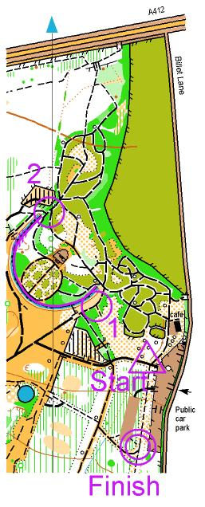

Parking
This is a public car park on gravel and charges must be paid on all vehicles parked there. The meters take cards or cash.

Cars Up to 3 hours : £2:70. Over 4hrs : £3.50

Minibus £8 per day

PLEASE NOTE: Those travelling by coach will need to contact Mel Elkington ( bsoasecretary@gmail.com) to be given instructions on what to do . This is because it is not possible for coaches to park at Langley Park. Even though the web-site shows the parking charge for coaches it is not possible for a coach to enter the car park. The access is down a narrow lane with access to the car park via a sharp turn with insufficient space for a coach to negotiate/turn around.
We hope to arrange alternative parking for coaches which will involve a short walk to the park.

Café and Toilets

There is a café and toilets at the northern end of the car park

The Event – 1 P.M. to 4:15 P.M (the park closes at 4:30 P.M)

Equipment Required
Personal gear needs to be either Orienteering kit or a T-shirt or long sleeved shirt, tracksuit bottoms and trainers (or good grip soled shoes). No Shorts or Jeans.
A compass is strongly recommended.

Terrain
Langley Park is a mixture of woodland and park land with a good path network

Training Maps
The maps and details of the permanent course can be picked up at Langley Park on the day. Some extra maps and details of the permanent courses will be available on the day at a cost of £2

Training Start & Finish
There will be someone present at the entrance to Langley Park with the maps, details of the permanent courses & your race numbers etc for BSOC from 1PM

Dogs
Are allowed on leads

British Schools Orienteering Association
The BSOA exists to provide a link between schools and mainstream Orienteering. It is affiliated to British Orienteering and has 300 schools as members. Teams representing BSOA are sent to the World Schools Orienteering Championships, which are held biannually. At present membership of BSOA is free.
For further details visit: www.bsoa.org

